JOY project
Innovative, Recreational, Stress Relief Youth Empowerment Strategies

2020-1-RO01-KA205-078667

Youth guidelines for effective learning and career planning

This project has been funded with support from the European Commission. This publication reflects the views only of the authors, and the Commission cannot be held responsible for any use, which may be made of the information contained therein.

Content

1.Introduction......................................................................................3

2. Self-knowledge……………………………………………………………………………….5

3. Self-assessment of my relations……………………………………………………17

4. Critically thinking on career and future…………………………………………26

5. Appropriate decisions, including choosing career and profession.…38

6. Effective communication………………………………………………………………50

7. Learning effectively for daily classes, exams, successful career and a fulfilling life………………………………………………………………………………………63

Introduction

Youth guidelines for effective learning and career planning is designed for youth between 14-20 years to help them deal with two main factors that cause high stress and anxiety, and thus leading to burnout: academic or school performance and the uncertainty concerning their future in terms of career choice and professional path.

Most of youngsters are worried about their future and feel high pressure, because they do not have sufficient self-knowledge and they don't know what they want, on one hand, and their critical spirit is not developed enough, on the other hand. Not knowing what they want, they easily adopt parents' wishes or advice from other people and let the others to decide for them which high school or university they will attend. And even if they know what they want, sometimes they are strongly influenced by parents or peers, because they do not have the courage or do not know how to follow their own professional path.

The consequence is often the dropout of high school or faculty in the first year. In addition, the fear of failure at exams is very common among youngsters, representing one main stress factor, because they associate high level of academic or school performance with getting a good life and a successful career.

It is known that one of the effects of digitization on youth is the fact that they live more in a virtual world, loosing their contact with the real world. This affects them by adopting false beliefs or making logical error in their thinking, as well as not knowing what are the professions of the future and labour market trends. At their age, the decisions are also based mostly on emotions.

Other issues youth are facing are related to career myths and their limiting beliefs, as the idea that once they have chosen a professional path they will never be able to change it. It is also worth noting that today's youngsters are
very much comparing to others and at the same time they label them based on social status, race, religion, disability etc. By developing critical spirit they will be able to correct their false and limiting beliefs, to escape from self-blame and make appropriate decisions for them, as well as to understand and include others.

The expected impact of this Youth Guidelines is to develop critical spirit in many areas of their live, emphasizing though the aspects related to career and to raise level of self-knowledge and selfawareness.

For this purpose, the guidelines are divided into chapters, addressing the following topics:

1.Self-knowledge: Who I am? (my personality traits, skills and competences, values, wishes, hobbies, occupational preferences, interests, previous experiences etc.).

2. Self-assessment of my relations (with parents, siblings, peers, friends, including knowing how I relate to them or if there are tendencies to label others based on their social status, religion, race, disability, migrant background etc.)

3. Critically thinking on career and future (addressing myths and limiting beliefs on career, logical errors).

4. How to take appropriate decisions, including choosing career and profession.

5. Effective communication (how to affirm my needs, rights, wishes, choices in front of others).

6. Learning effectively for daily classes and for exams and having an appropriate mindset in order to have a successful career and a fulfilling life.

Each chapter of guidelines is structured on tips, suggestions and attractive theoretical elements, self-assessment part, practical exercises and self-reflections, ending with available resources for those who want to know more on a certain topic.
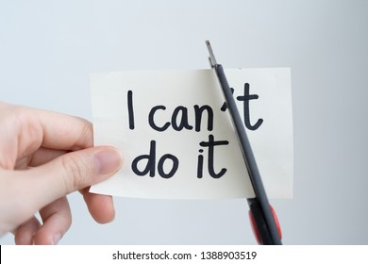

1.Self-knowledge

The vast majority of people believe they have a decent amount of self-awareness, about 95 percent. In fact, a pretty small percent, about ten, has an accurate view of themselves.

The psychologist Tasha Eurich, in her book Insight provided these statistics based on years of research. “On a good day, 80 percent of us are lying to ourselves about whether we’re lying to ourselves,” Eurich mentioned in her book. Making things extra tricky is the fact that self-awareness has two components: Internal self-awareness is the ability to introspect and recognize your authentic self, whereas external self-awareness is the ability to recognize how you fit in with the rest of the world. “It’s almost like two different camera angles,” Eurich also mentions.

The two are independent, entirely different variables, meaning you can have one without the other. For example, maybe you know someone who is a complete navel-gazer with a high level of internal self-awareness. Yet you and everyone else think this person is a selfish jerk, but because he never receives external feedback, he has no idea. Conversely, someone could have a high level of external self-awareness, a clear understanding of how they fit in with the rest of the world, without knowing what they want and what makes them happy. To be truly, fully self-aware, though, you need both components, a feat that’s difficult to pull off for pretty much anyone. But it’s worth noting, not impossible.

Self-knowledge – always a challenge

“We villainize people for not being self-aware when all the decks are stacked against us,” Eurich explains. “Pretty much all over the world, forces are conspiring to make us more self-absorbed, which is basically the opposite of being self-aware.” Modern life makes it easy to become a part of what Eurich calls the “cult of self”: social media, for example, acts as a microphone-slash-spotlight we never have to turn off, while the concept of “personal branding” turns careful image curation into a professional skill. None of this is to suggest you should shut down your Facebook profile, Eurich says, but these elements can serve as environmental blocks to self-awareness: “Whether or not you know it, the cult is trying to recruit us all.”
Our environment isn’t the only obstacle. We are all built with our own internal blocks as well. In a 2010 TED Talk titled “The Riddle of Experience Versus Memory,” psychologist Daniel Kahneman noted that our memories are often inaccurate, which makes introspection difficult. In his book, Thinking, Fast and Slow, he writes: “Except for some effects that I attribute mostly to age, my intuitive thinking is just as prone to overconfidence, extreme predictions, and the planning fallacy as it was before I made a study of these issues. I have improved only in my ability to recognize situations in which errors are likely … And I have made much more progress in recognizing the errors of others than my own.”

Kahneman is alluding to the “bias blind spot,” our tendency to recognize cognitive biases in others without noticing them in ourselves.

In other words, your brain isn’t built to easily spot your own lack of self-awareness. It may seem like a futile pursuit, but Kahneman offers an answer that’s a little bit hopeful, even if it’s also a little bit frustrating. “What can be done about our biases?” he writes. “The short answer is that little can be achieved without considerable investment of effort.”

Moving past these blocks first requires acknowledging where you’re starting from. Indeed, “the most powerful thing you can do is to gently stop assuming you’re already self-aware,” (Eurich, 2018).

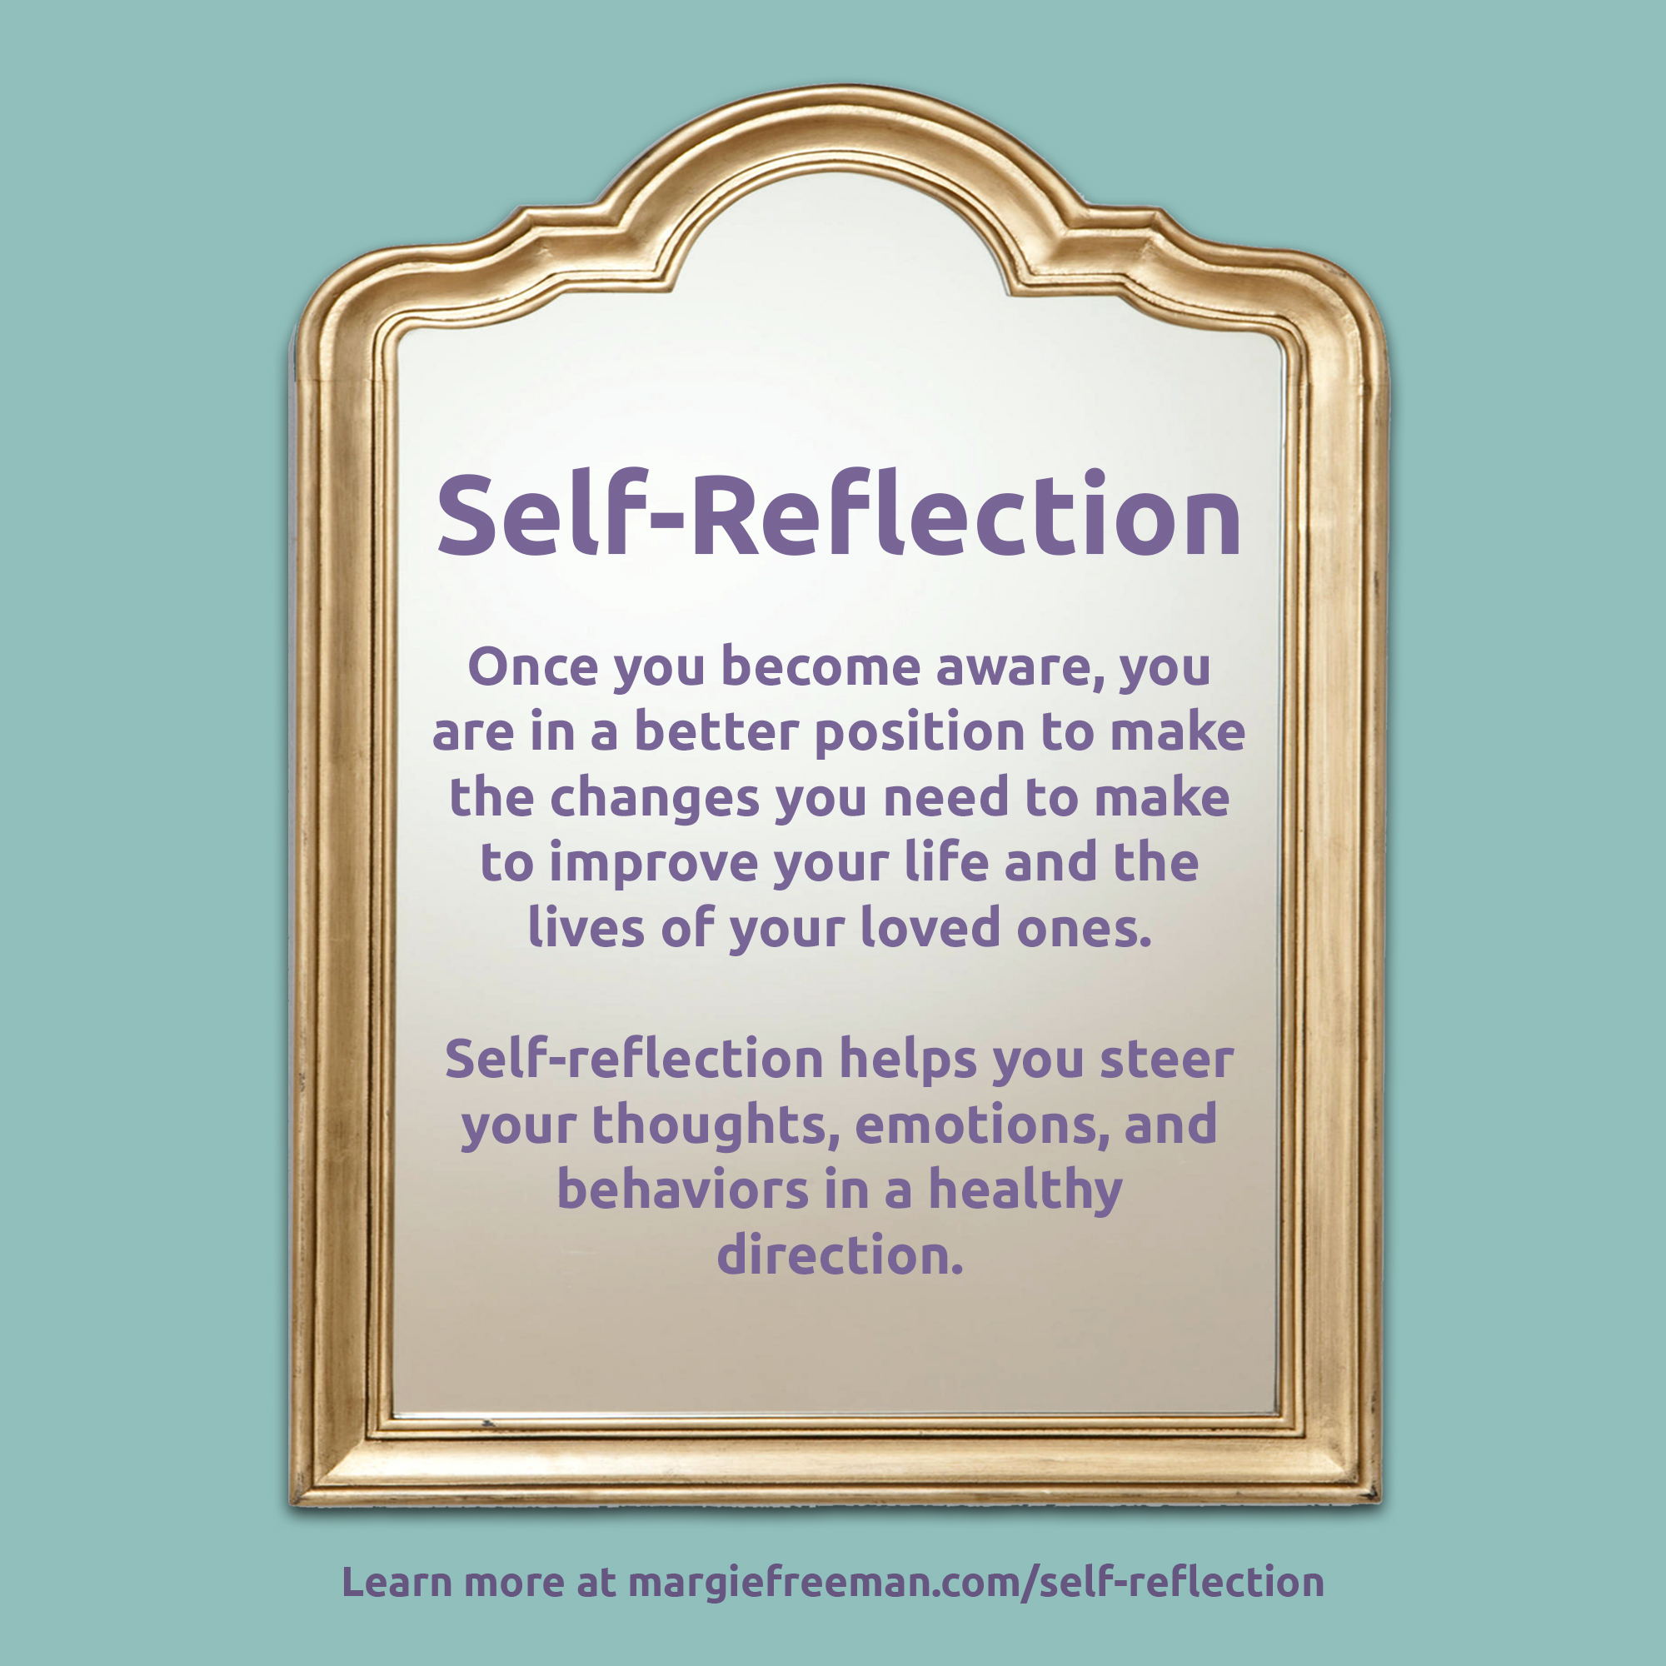

There are countless benefits to self-awareness, from stronger relationships to increased well-being. For example, in a study made by Cornell University, they examined the traits that contribute to the effectiveness of successful leaders, concluding that a high level of self-awareness was the strongest predictor of success.
It wasn’t a particularly surprising finding, the paper noted; when leaders are self-aware, they know how to hire subordinates who are strong in the areas where they themselves are weak. “These leaders are also more able to entertain the idea that someone on their team may have an idea that is even better than their own,” wrote the authors. Confidence and power are often prioritized in leadership roles, they added, and “leadership searches give short shrift to ‘self-awareness,’ which should actually be a top criterion.”

Why Self-Acceptance is important

Only because self-awareness is a desirable trait doesn’t mean it’s one we enjoy having. In a series of studies published last year in the Journal of Personality and Social Psychology, researchers asked subjects to engage in conversations with strangers, acquaintances, close friends, and loved ones, comparing the impression participants made on their conversation partner to the one they thought they made.

The subjects enjoyed the interactions less when they had an accurate view of how they were perceived. When they had high levels of external self-awareness. “People tend to like individuals who have accurate self-perceptions, yet individuals tend to enjoy their own relationships more with people they believe see them in desirable ways,” according to the authors. In other words, ignorance can be bliss when it comes to external self-awareness; like a heavily filtered Instagram, we’d rather people see a better version of ourselves, even if that version isn’t quite accurate.

This is why self-acceptance is a necessary ingredient in self-awareness. “Self-acceptance is a really important tool to not just increase our self-awareness, but also love the person we think we are,” mentioned Eurich. “You can think of them as two twin pillars.” Without self-acceptance, self-awareness becomes an unpleasant process, which in turn keeps us from embracing it. In other words, learning to accept yourself makes it easier to be honest about who you are.

Introspection matters

Introspection is key to building internal self-awareness, but aimless wandering through your own psyche probably won’t get you very far. You need a framework. Eurich has identified seven pillars of self-knowledge to help guide introspection:
- your personality,
- values,
- passions,
- aspirations,
- strengths,
- weaknesses, and
- the “fit,” which is the environment most conducive to your well-being.

You may start by giving yourself the time and space to mull over each of these areas.

Eurich has even created a 14-question quiz to help you along: Insight: The Quiz (insight-book.com)

Of course, your approach matters, too. When introspecting, it’s common for people to ask “why”: Why didn’t I get a better grade? Why do I keep arguing my parents about my future? Research has shown there are two problems with this. The question ‘why’ may send us into an unproductive, paralyzed state. It gets us into the victim mentality. Second, no matter how confident we are about the answer to “why,” we’re almost always wrong.

What are self-aware people doing differently? They are almost never asking why, but they were asking themselves:
“‘What knowledge and skills do I need in the future?”
“What don’t I know?”

Why questions are emotionally charged, whereas what questions are rational and figure-focused, making it easier to approach a problem objectively.

Ask for several opinions

To build external self-awareness, on the other hand, you need to let someone else answer the questions. Asking someone close to you what they think about you, potentially even using the framework of those seven pillars. You need to go in the outside world and get feedback from people you trust, people who want you to be successful but are also going to tell you the truth.

You should also gather feedback from multiple “loving critics,” to ensure you aren’t only getting one view.
Another loved one might see you in a completely different light. While you don’t want to outright dismiss any feedback or criticism, you do have to learn to think objectively. Getting a second, or third, opinion can help. In the end, though, it’s on you to synthesize all those opinions into a cohesive self-portrait and then get acquainted with the result.

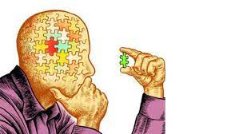

Other psychologists see self-awareness from reflecting on three aspects of the 'Self':
1). 'I-Self' – This aspect answers the question, 'How do I see myself? ...

2). 'Me-Self' – This answers the question of 'How do others see me? ...

3). 'Ideal-Self' – This answers the question of 'How do I want others to see me?

Knowing oneself has immense benefits, which can help oneself in setting realistic goals, accomplishing tasks, having successful relationships, or simply remaining motivated in their daily activities. In order to perform at an optimum level, knowing oneself is of top importance!
Self-awareness stems from reflecting on three aspects of the ‘Self’:

1). ‘I-Self’ – This aspect answers the question, ‘How do I see myself?’ Reflecting on the concept of ‘I-Self’ helps the individual to understand oneself from life’s learning experiences including past experiences, accomplishments, mistakes, attitudes, behaviours or values. These experiences mould one to become who they truly are.

2). ‘Me-Self’ – This answers the question of ‘How do others see me?’ This aspect of the self is developed from influences and interactions with society. Parents, friends, teachers, mentors and any environmental factors can contribute to the shaping of the ‘Me-Self’. The ‘I-Self’ is constantly developing as the ‘Me-Self ‘evolves.

3). ‘Ideal-Self’ – This answers the question of ‘How do I want others to see me?’ This is a projection of oneself onto others and the fulfilment of various roles in one’s life journey.

Creating a unified self is constantly challenging as often, the three aspects of ’SELF’ are not in sync with one another. People are generally wired to seek meaning and acceptance. However, what one conceals from the public can be the catalysts hindering the quest for social acceptance. For instance, when the urge to control the perception of others overwhelms the authentic self, self-awareness will be gradually diminished, resulting in a loss of identity.
It is therefore of high importance to know oneself as it aids in identifying personal weaknesses, realising areas of improvements, identifying optimal choices in decision-making and the sharing of strengths with others. Ultimately, knowing and understanding oneself leads to a more productive life and in attaining one’s goals.
Self-awareness

It is always important be become more self-aware in order to smoothens your path to personal and professional success. By giving us a better understanding of who we are, self-awareness lets us better understand what we want to achieve in our life, what we need most from other people, helps us complement our own deficiencies and prevent failures.

Self-awareness lies at the root of strong character, giving us the ability to lead with a sense of purpose, authenticity, openness, and trust.
Here are some tested ways to cultivate and develop self-awareness.
- Meditate. As meditation is the practice of improving your moment-by-moment awareness. Most forms of meditation begin with focusing on, and appreciating the simplicity of, inhaling and exhaling. But these don’t need to be formal or ritualistic — greater clarity can also come from regular moments of pause and reflection. It is extremely useful to find a few seconds to focus on your breathing, often before sleep, and sometimes with one of the many apps available to help. During these meditations, you can also ask yourself a set of questions, among them:
- What am I trying to achieve?
- What am I doing that is working?
- What am I doing that is slowing me down?
- What can I do to change?
You can simply practice “meditation” during mundane tasks that inspire a degree of therapeutic serenity, including coming back from school, washing dishes, cleaning your room, preparing sandwiches etc.
- Write down your key plans and priorities. One of the best ways to increase self-awareness is to write down what you want to do and track your progress. Warren Buffet, for one, is known for carefully articulating the reasons he’s making an investment at the time he makes it. His journal entries serve as a historical record that helps him assess whether or not future outcomes can be attributable to sound judgment or just plain luck.
Li Lu, a co-leader of the Tiananmen Square student demonstration and today a highly respected investor, wrote about a practice he followed for years, inspired by Benjamin Franklin. Franklin kept a “balance sheet” of both the assets and liabilities of his personal traits. By diarizing any new strength, he believed he could learn from someone else, and marking down any self-perceived weaknesses, he could better assess whether the “net worth” of his character was growing over time.
- Take psychometric tests. Thus you can understand which of your traits are most likely to be biased in business-building and in life. You may take a simple entrepreneurial aptitude test (that you can take for free at www.hsgl.com) or other tests, but all are aimed as serving as a data point towards greater self-awareness. A common design point with all psychometric tests is that there are no particular right or wrong answers. Instead, they are designed to compel respondents to consider a set of traits or characteristics that most accurately describe them relative to other people. Reflecting on the questions helps you better understand your own true character.

- Ask trusted friends. Sometimes you need the feedback of our peers, friends, and mentors. To have your friends play the role of honest mirror, let them know when you are seeking candid, critical, objective perspectives. Make your friend or mates feel safe to give you an informal, but direct and honest view. This can mean saying something like, “Look, I am actually asking you as a friend, please just be straight with me on this matter. Okay? “
Another strategy is to ask friends to call you out when you are doing a behaviour you already know you want to change. For instance, “Look, I know I am a ‘story-topper’ who needs to one-up every conversation, but do me a favour and each time I do that, let me know – preferably discreetly – so I can learn to stop.”
- Get regular feedback at school. In addition to informally and periodically asking friends and family, use the formal processes and mechanisms from school. If none are in place, see if you can implement more formal feedback loops. Provided it is done well, constructive, formalized feedback allows us to better see our own strengths and weaknesses.
Building self-awareness is a life-long effort. You’re never “done.” But these five pragmatic practices will help you move faster and further along the way.
Self-management
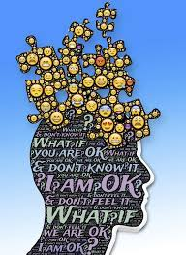
Leaders need self-awareness to be effective — that is, an understanding of their strengths, weaknesses, feelings, thoughts, and values, as well as how they affect the people around them. But self-awareness is useless without self-management, a very important skill.
It’s a four-step process. Start by being more present. Pay attention to what is happening in this moment — not what was said 15 minutes ago or what will happen in your next meeting. Second, practice self-awareness. What are you seeing, hearing, feeling, doing, saying, considering? Third, try to identify a range of behavioural choices. What do you want to do next? What are the possible consequences of each action? What feedback have you gotten that might inform your choices? What are some alternative choices you can make — even if they’re not what you want to do or what you usually do. Finally, intentionally choose behaviours that are believed to be the most productive. What behaviour will generate the best outcome — even if it’s not the behaviour that comes easiest to you.
Self-management is a conscious choice to resist a preference or habit, and instead, demonstrate a more productive behaviour. It’s a four-step process:
- Be present. Pay attention to what is happening in this moment — not what was said 15 minutes ago or what will happen in your next meeting.
- Be self-aware. What are you seeing, hearing, feeling, doing, saying, and considering?
- Identify a range of behavioural choices. What do you want to do next? What are the possible consequences of each action? What feedback have you gotten that might inform your choices? What are some alternative choices you can make — even if they’re not what you want to do or what you usually do?
- Intentionally choose behaviours that are believed to be the most productive. What behaviour will generate the best outcome — even if it’s not the behaviour that comes easiest to you?
What makes self-management so hard goes back to the definition. The most productive behaviors are often not aligned with our habits and our preferences. (If they were, we would not need to manage ourselves.)
Behaving in ways that aren’t aligned with your preferences can make you feel uncomfortable (“I always respond first in class. I worry others won’t get it right”), unskilful (“I don’t know how to give negative feedback to a mate”), and even unpleasant (“I like being direct and get impatient when I have to choose my words carefully”).
Operating in ways that contradict our habits can evoke similar negative reactions. With a habit, our brain creates a shortcut and moves from stimulus to response without thinking, saving both time and effort. But non-habitual behaviours require us to think about a situation, consider choices, make a choice, and then demonstrate the behaviour that aligns with that choice. This takes work. The auto-pilot efficiency of habits is what make them so hard to change. It’s easier and more pleasant to default to an old habit than it is to invest the energy in creating a new one.
Despite these barriers, self-management is a learnable skill. This is how you can start:
- Decide where you want to self-manage. Pay attention to how you typically operate — what you say and do and what you don’t say and don’t do. Identify instances where your current approach is not working as well as you’d like, and self-management might be useful. For example, maybe, like Rick, you talk too much in meetings.

- Notice and reflect on what’s driving your lack of self-management. In those moments where you’re not self-managing but would like to, notice how you feel, what you want, and how you are interpreting what’s going on around you. What is driving your actions? Is it lack of awareness in the moment, wanting to look good, lack of skills, insecurity, or something else? Those of us who have a bias for action may be tempted to skip this step of reflection and move straight to planning and practicing — but don’t. Understanding why we make the choices we make is crucial to changing those choices.

- Consider your choices and your reactions to those choices. Instead of your default behaviours, if you were self-managing, what else could you do? What is your reaction to those options? Notice how your preferences and habits show up here, and ask yourself what you are trying to avoid when you default to those habits and preferences.

- Make a plan. Now that you know what you want to change, better understand what’s driving you, and have identified some options, think of concrete steps you can take.

- Practice. Old habits are hard-wired into our brains. To change them, we need to create new neural pathways (new habits), and this requires practice. Do this repeatedly until you are consistently able to self-manage that behaviour. At the same time, explore your reactions to your practice. What can you learn from what you’re doing, and from how you’re reacting, that can inform your continued practice?

- Repeat the process. Go back to step two and observe your efforts, reflect on your choices, revise the plan, and practice some more. In each successive iteration, you’ll learn a bit more about how you’re operating, what’s driving your behaviour, and how you can improve it.
It’s natural to behave in ways that feel good and familiar — to not self-manage — and yet, if we did this all the time, we’d never get better at anything. To become as effective as possible, leaders move beyond self-awareness to self-management. Start by recognizing your current actions, considering alternative options, and then putting in the hard work required to resist what may be most familiar or comfortable. Instead, commit to effectively executing what is most productive.

Activities for increasing self-knowledge

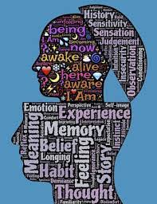

Activity 1. Take a piece of paper reflect on your interests, values, important things for you and draw your coat of arm. Show it to your best friend and explain it to her/him.

Activity 2. Take a sheet of paper, several old newspapers, glue and a pair of scissors. Choose three images that represent for you and glue them on the sheet of paper horizontally from left to right. Take a moment of reflection when the college is ready. The image on the left illustrates your part, the one in the middle, your present, the one on the right your future. Are you happy with the image illustrating your future? How do you see it? If you are not happy you can cut another image in the newspaper and replace the one on the right. How do you feel now?

Activity 3. Take this self -knowledge questionnaire as sincerely as possible:
-What do I need more in my life?
-What would make me happy right now?
-What am I grateful for?
-What do I love about myself?
-What are my victories and successes?
-What is going right in my life?
-What`s bothering me? Why?
-Whom I love best and why?
-If I could share a message to the world, what would it be?
-What`s draining my energy? Why? How can you change this?

Activity 4. Write constantly a positive diary about yourself.

Activity 5. Choose a pop song that you like and that you feel it represents you at present. Listen to it and sing it whenever you feel bad with yourself.

References:

Eurich, T. (2018). Insight: The Surprising Truth About How Others See Us, How We See Ourselves, and Why the Answers Matter More Than We Think, Currency.

- Kahneman, D. (2012). Thinking. Fast and Slow, Penguin.

- https://hbr.org/2019/06/how-to-move-from-self-awareness-to-self-improvement?ab=at_art_art_1x1

- https://hbr.org/2015/02/5-ways-to-become-more-self-aware

- https://www.yourtrainingprovider.com/the-5-elements-of-self-awareness/

- http://www.self-knowledgeforhumans.com/beginners-guide.html

- Insight: The Quiz (insight-book.com)

Additional information:
https://www.youtube.com/results?search_query=self+awareness+activities

2. Self-assessment of my relations

We are not alone in this world. Your relations start in childhood with parents and siblings, later in peers and friends in the kindergarten and school. We communicate with people outside home and school, some we know, some are unknown. Social media offers opportunity to communicate with many people who are behind the screen and we also know some of them and some are unknown.

It is not easy to build positive healthy relationships. You are lucky if all people around you are good and you did not have any troubles in the relationships. Unfortunately, most of young people experienced problems in relationships where there were or even are now tendencies to label people based on the social status, religion, race, disability, migrant background, etc. Many youngsters are victims of bullying and cyber-bullying. To understand, why it happened, what is wrong with you or others, is important to make self-assessment of relations.

Relationship satisfaction
The quality of relations has an impact on many areas of life. Good working relationships can be significant resources to cope with difficult life situations and stress when you, for example, have problems with learning at school, and may contribute to well-being and healthy lifestyle. Therefore, its investigation has particular relevance.
There starting point can be analysis of:
- Relationship satisfaction.
- Relationship realism.
- Relationship possible growth.
Relationship satisfaction is the positivity of feelings with other person/ people.
Ask yourself:
- Are you happy with your parents and siblings?
- Do you like your friends and classmates?
- What new relationships would you like to build (new friends at school, in sport club, social media, etc.).
You can go further and ask questions about your relationships with peers with same age, your teachers and other adults. You can write your answers, so can come back to them later and analyse after some time (week, months, year).
If you need feedback to your analyse, think with whom you can discuss your written notes: patterns, siblings, friends, teachers? Maybe, you prefer to speak with people you know and also with people you don’t know.
Some methods offer self-assessment of relationships with the use of mandalas, via music and films.

Relationship realism
It is not secret that in relationship one person give more than other. According to interdependence theory, people want to maximize their rewards and minimize their costs in a relationship. It is important to understand and agree on the common “currencies” valued in relationship.

For example, to give and to get are visibility and recognition. People value visibility when they want their skills, capabilities and talents to be noticed and utilized. Visibility improves chances of being asked to be part of cool and important projects or games. All want to be thanked and appreciated for their study, work or performance. Different people may prefer different types of recognition.
Ask yourself:
- How well do you understand the other person’s world?
- What do he/she value?
- What can you give to him/her/them that falls within their value system?

Relationship possible growth
In happy relationships, people typically have a sense that they're growing as a person due to being in the relationship.
- Your friend sees you more positively than you see yourself. You get an expanded sense of your positive attributes or talents.
- Your friend introduces you to things you like. You get new opportunities for pleasurable experiences and an expanded sense of self. For example, say your friend enjoys bicycle camping, and maybe you never would've tried this if it wasn't for your friend's influence.

- Your friend's good habits rub off on you—including health, finance, lifestyle, or psychological habits. For example, health-related habits could include flossing to jogging.

- Your friend encourages you to be yourself. For example, you love singing. You sing all the time at home and your friend encourages you to sing in a concert. Or perhaps you're a very fun person who loves to joke. Your friend also loves to joke, or just likes your joking and sense of fun and supports you expressing this positive aspect of yourself.

- Your relationship provides practical support that allows you to pursue your personal goals. For example, you can start to do something creative because you can rely on your friend.

- Your relationship provides emotional support that helps you persist with hard things. For example, this support could come while you're at graduate school and thinking about career. On days when you're feeling disappointed or demoralized, you can hug your friend.

- Your relationship helps you learn to trust that another person will be dependable and emotionally available to you. If you start out most relationships being very worried that your friend is going to abandon you but, over time, you realize this doesn't happen, you'll become more trusting and open.

- Your relationship helps you learn to trust that you're an emotionally dependable person. You might doubt your own capacity to be a reliable support to another person, but over time you realize you're emotionally dependable. You grow because you learn you have the capacity to emotionally support your friend.

- Your relationship helps you with self-acceptance. You learn to take emotional risks with your friends. You tell them about things you're anxious or ashamed about—and they still love you, which often helps with self-acceptance. For people who worry that they're unlovable, a good relationship can prove this wrong.

- Your friend doesn't appreciate or support your negative patterns and thus makes you more willing to change in positive ways. For example, that your friend doesn't tolerate you being excessively dramatic. You learn there is no benefit to this and stop for the sake of the relationship—but it also helps you elsewhere in your life. Perhaps, your friends do not let racist or homophobic statements slide, even unintentional ones. They call you on these things and you change for the better.

Task: Self-Reflection
If you enjoy self-reflection, try writing an example from your own relationship that fits into each of the above ten categories.
Your relationships are as flowers, they need attention and care for growth, otherwise they will die.
Ask yourself:
- How strong are your relationships? What are strengths and weaknesses, threats and opportunities for growth?
- What actions can you take to strengthen them?
- What do you want really to get out of this relationship?

Task:
- Read DISC and mark 10 more appropriate words describing you.
- Choose among these ten words five more important.
- Choose among these five only three, write on separate paper and write for yourself why do you think that these words characterize you in the best way.
- Do you like what you read about yourself? Would you like to improve or develop something and be different than you are now?
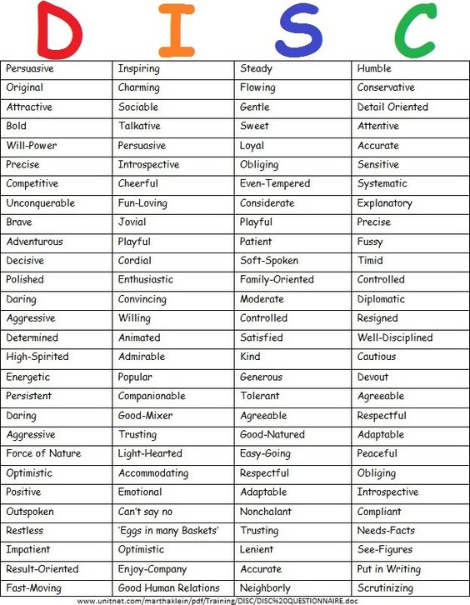

Self-assessment tools
Self-assessment is a powerful learning strategy and can be used not only for analyzing relationships. Students who can assess their own learning are more effective learners. They are more motivated and engaged, have a greater belief that they can succeed, and are able to adapt their approach if learning is not working. Assessment-capable students show higher achievement. While in the long-term self-assessment facilitates self-directed learning by students, establishing successful self-assessment requires considerable input by teachers.
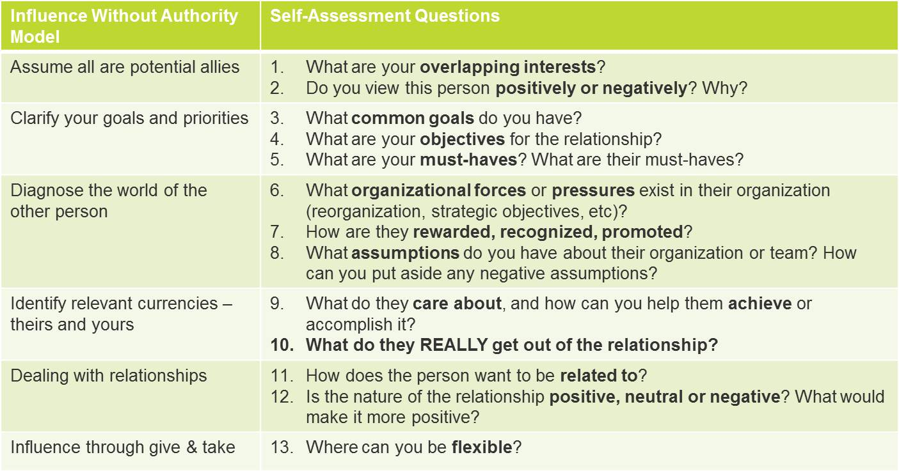
Source: https://www.people-results.com/influencing-authority-tools-building-relationships-work/
Here are eight tools, which may be useful in developing self-assessment practices. They can be used also to analyse relationships:
- Rubrics
- Scripts
- Journals
- Portfolios
- Traffic lights
- Exit cards
- Paired marking
- Dedicated Improvement and Reflection Time (DIRT)

Information how to use this tools is on https://theeducationhub.org.nz/8-tools-for-peer-and-self-assessment/
There are many other tools to make self-assessment. Some are simple and efficient, like, for example, this one:
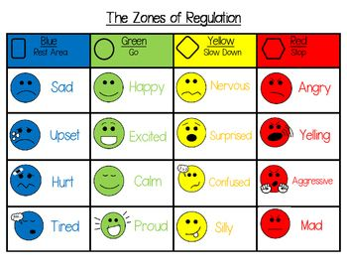
Source: https://www.pinterest.co.uk/pin/1125968643232214/
Publications and helpful resources
The Relationship Self Assessment written by Bart Allen Berry is a powerful self-examination of one’s relationship behaviors. It will examine the quality and satisfaction of relationships with others as well as with one’s self. This instrument can be delivered to a diverse range of people from age 15 to adult or taken as a self-assessment instrument. Bart Allen Berry is consultant and founder of 30-years old San Diego Corporate Training. He created a baseline measurement of relationships with others, friends, family, external self and internal self. A thirty questions self-analysis process gives you overall mean score as well as category averages and individual question scores represented on the Relationship Impact Chart. A self- improvement and planning guide are included.
You can use for yourself Relationship Scales Questionnaire – RSQ where on a 5-point scale‚ you can rate the extent to which each statement best describes their characteristic style in close relationships. Five statements contribute to the secure and dismissing attachment patterns and four statements contribute to the fearful and preoccupied attachment patterns.
The Relationship Structures Questionnaire (ECR-RS) is a self-report instrument designed to assess attachment patterns in a variety of close relationships. The same 9 items are used to assess attachment styles with several different people‚ for example mother (or a mother-like figure) ‚ father (or a father-like figure) ‚ current (or a former) romantic partner‚ and best friend (or close friends more generally). With adaptations‚ the statements are also relevant to therapeutic relationships.

The ECR-RS can be used as a 9-item version of the two 36-item Experiences in Close Relationships Questionnaire – Revised (ECR-R).The statements are about how you feel in emotionally intimate relationships. You can use them to assess how you tend to feel in close relationships generally‚ or to focus on a particular relationship or type of relationship. Using the 1 to 7 scale‚ after each statement write a number to indicate how much you agree or disagree with the statement when applied to the relationship(s) you are looking at.

You can find long form with 30 questions about Child-Parent Relationship Scale and with 15 questions to analyse your relationships in family.

If you are about to build relationship with boyfriend/girlfriend, it will be useful to learn about relationship in couples and read about that Couples Self-Evaluation.

References:
- 1. Bart Allen Berry. Relationship Self-Assessment. 2018.
- https://www.amazon.com/Relationship-Self-Assessment-Measurement-Relationships-Friends/dp/1730761763

- Griffin & Bartholomew. Relationship Scales Questionnaire (RSQ).1994.
https://scales.arabpsychology.com/s/relationship-scales-questionnaire-rsq/

- The Relationship Structures Questionnaire (ECR-RS)
https://scales.arabpsychology.com/s/relationship-structures-questionnaire-ecr-rs/

- Experiences in close relationships questionnaire
https://scales.arabpsychology.com/s/experiences-in-close-relationships-questionnaire-revised-ecr-r/

- Child-Parent Relationship Scale
https://scales.arabpsychology.com/s/child-parent-relationship-scale/

- Couples Self-Evaluation
https://hopeallianz.com/wp-content/uploads/2018/07/Couples-Self-Evaluation.pdf

Alice Boyes. 10 Ways Relationships Help Individuals Grow
https://www.psychologytoday.com/us/blog/in-practice/201206/10-ways-relationships-help-individuals-grow

- 8 tools for peer and self-assessment
https://theeducationhub.org.nz/8-tools-for-peer-and-self-assessment/

Influence Without Authority: Tools for Building Relationships at Work
https://www.people-results.com/influencing-authority-tools-building-relationships-work/

- Healthy Relationship Assessment: Questions To Ask Yourself [2019]
https://www.youtube.com/watch?v=NejemlBXKpM

- Student self-assessment
https://www.youtube.com/watch?v=RSoIgPMT9AE

- The wheel of life: A self-assessment tool
https://www.youtube.com/watch?v=aKGm3nprVA0

- Self and Peer Assessment Overview https://www.youtube.com/watch?v=1wwo09Lb9hw

- https://www.pinterest.co.uk/pin/1125968643232214/

3. Critically thinking on career and future

In this output, we present several career myths linked to vocational subjects. The output contains a discussion about errors of thinking and how to change the mindset.

We also present some exercises of positive thinking connected to the growth of our mindset and enhancing of social skills.

The labour market and the 21st-century work environment require social skills more than ever before, and it is no longer sufficient to have a wide variety of technical skills if you are unable to work with people. The importance of social skills is therefore presented first.

Social skills

Further research shows that several factors are important for the student's professional learning (Hattie, 2008) and for how they succeed with education and work. Here is a model that shows the connection between those factors.

Lots of research from last ten years (e.g. Bailly and Lene 2013) shows that social skills are becoming increasingly important in the labor market. Several professions have work tasks that require higher social skills than before, and interaction with peers, customers and people from all over the world is more vital than ever before. If we look at the figure below, we see that the two lines that represent high social skills increase over the years. The two lines that represent low social skills have decreased over the years. Furthermore, the research says that there is a high probability that this trend will only increase in the next few years.
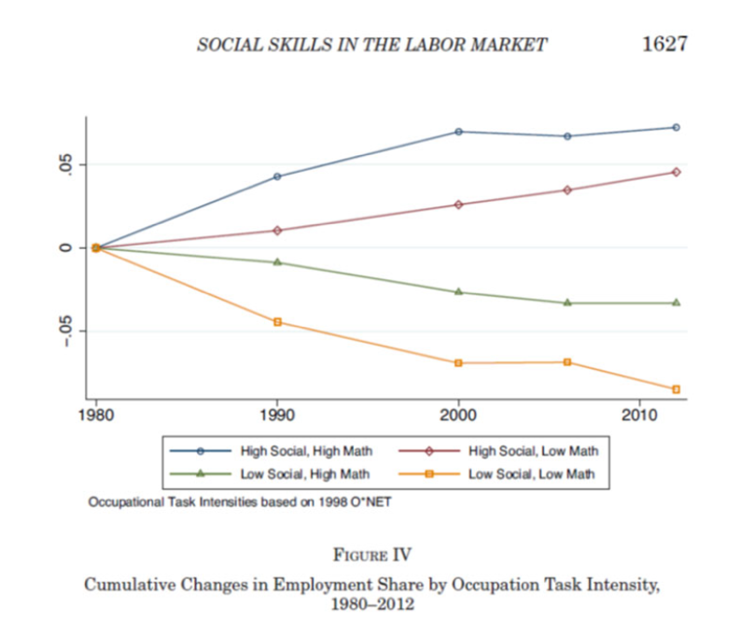

In working life, there is an expectation that one can take on different types of challenges and not be afraid to make mistakes. Having the ability to flexibly adapt and collaborate with employees of several types is very important for many employers. Being flexible, creative and taking initiative are also important qualities that is expected of our young people. All of these qualities are also important to be able to learn new things, master new tasks and create opportunities for oneself.

Social skills can be developed and learned. At Godalen Vocational college, we have a structured approach we use to work more systematically with the students' social competence. See form below.

Core elements within the five basic dimensions of social competence:

Cooperation | Empathy | Self-assertion | Self-control | Responsibility
Communicate clear and good with teacher and fellow students | Report if  he/she sees someone  who are lonely or need help | Can admit mistakes and apologize | Follows the rules in  classrooms and  workshops | Greetings to fellow students,  teachers and staff. E.g. good morning
Confirms and is  positive towards others | Actively contributes to  no one is being bullied | Can say no and set your own boundaries | Contributes to others  learning and the school work peace | Follows teacher's  instructions and contributes  to strengthen the teacher's  role as leader
Follows the rules in classroom and workshop | Accept that we are all different but work towards same goal | Can hold one  presentation for a group of fellow students | Follows the teacher's  instructions | Contribute to a tidy school and nice student environment
Communicates well  with peers | Meet other students  as he/she wants to be  met him/herself | Ask for help in an respectable and  appropriate manner | Sitting at their place in the classroom  and works when it is  expected | Listens when  the teacher speaks and  gives messages without  provoking or being  negative
Listens to classmates  and teacher in a respectful way | Goes well together  with peers | Handles/  regulates feelings in an  appropriate manner | Follows the rules yourself  when peers  encourage to  break them | Shows good  work attitude and interest
Takes initiative beyond what is expected  in the situation | Recognizes and shows under-standing of the feelings of others | Resolves conflicts with peers without help from adults | Behaves like  expected outside  workshop and  the classroom | Meets punctually, focuses and is prepared

Picture by Cathrine Neresen, Godalen Vocational College.

5 tips for developing social skills

1. Tell and explain what is expected - do not tell what is not expected.
2. Bring students into conversations about why each skill is important.
3. Be specific and show the student what is expected. Practice together.
4. Recognize students' positive social actions.
5. Be upfront - encourage students to show their social skills - do not wait for the "crisis".

Youth are told a number of career myths that might influence the way they think and the way they perceive the future when it comes to jobs, opportunity and the way forward. We will try to cover some of the classical myths and see what can be done to overcome this way of thinking.

Career myth number one:
"Academic subjects are the best way to hold on to all possibilities.
If you take vocational subjects, then you cannot take higher education"

Even if you study vocational subjects, it is possible to take higher education. You will not lose any opportunities, but it will take longer. And if you are bored with school it is very wise to start with something that gives mastery quickly and gives a sense of belonging and pride.

There are different pathways in every country for this but an example may be; You choose to study construction for two years and be an apprentice for two years. Once you have received a Journeyman certificate, you can always build on that and take the academic subjects necessary to be ready for university. You can also in many countries apply for a validation of prior learning when seeking admission to higher education. There are different rules for this in every country although the EU has tried to make this more common with several initiatives.

After a Journeymans certificate and some academic studies and later in life, it is possible to apply to university and take higher education.
The advantage of this model is that you are older and more mature. You may know what you want to become and have a clear goal of where you want to end up. In addition, you have work experience and a certificate of that does well on your CV. It can even make you stand in front row of the line when you apply for a job.

Career myth number two:
"Vocational subjects are suitable for students who are tired of school"

Vocational subjects are not necessarily more appropriate for school-tired students. The industry has developed to become more technical and requires more knowledge than before. The 21st century skills necessary to cope on the work market is not the same as before.

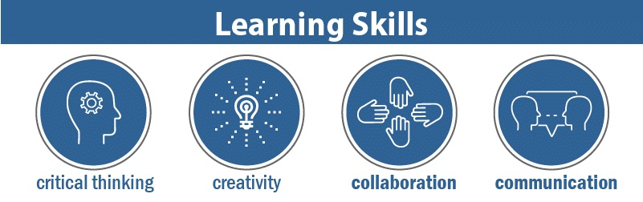
Pic. from https://www.aeseducation.com/blog/what-are-21st-century-skills.

At the same time, vocational subjects are more practical and it can be motivating to create something and get a relatively quick feeling of mastery. Having said that, it does not mean that vocational subjects are suitable for everyone, especially when there are so high demands for teamwork skills as shown in figure above.

Career myth number three:
"If you choose a vocational subject, you use only your hands, not your head"

Although vocational subjects are practical subjects, this myth does not hold to be true. Most industries have evolved to become more technical and in the mechanical industry for example, there is no need for the guy who sweeps the workshop or oils the machines. Now the mechanical worker can have the task of operating a computer in order to find the faults on the car or programme a 5 million Euro machine to produce parts making sure it does not stop for 1 minute of downtime. Workers must be able to read and understand a quite complex machine or operating descriptions and drawings. In several professions, work reports and other documents must be provided, often very specified according to international ISO standards. Vocational subjects also place high demands on thinking creatively and being solution-oriented. Both hands and head are actually used here.

Career myth number four:

"Education and past experience matter more than skillset."

The hiring practices in most modern thinking companies have changed towards thinking that past experiences might not be the best measuring point. They tend to be more interested in the person's actual skills that can be incorporated into the NEW job. This is called transferrable skills and means measurable competencies of all kinds that the employee can bring into the new position.

Career myth number five:
"You have to know someone to get hired."

Knowing someone and job referrals are quite cost-efficient ways of hiring new staff, and a Jobvite survey of recruiters showed that this way of hiring decreased from 51% to 31 % just over a few years. Factors that became more important were obtained certificates, resume format, cover letters, and online social presence. The reason why this is less important is amongst other factors that people who refer tend to refer someone who are quite similar thinking to themselves. This is actually quite a hindrance to a diverse workforce.

Career myth number six:

"Vocational training is for students with poorer grades"

The European education system is heavily focused towards academic intelligence, often leaving young people with below-average grades feeling incapable and unsuccessful. Here is the irony. We are often willing to pay more for our children to attend extra lessons or focused classes. However, in the end, parents and schools still look to their academic grades alone to determine if they are a well-performing student. How about young people's critical and creative thinking skills or public speaking and leadership traits?
These strengths often go unnoticed. Vocational training is an alternative to traditional academic studies. While the latter takes up a theoretical approach, vocational schools promote learning by doing. Different teaching methods work well for different students based on their learning preferences, not one being superior to the other. If the youth learn better by hands-on teaching and enjoy the application of theories learned, vocational training provides a platform for them to excel.
Instead of labelling them as ‘poor students who can’t study, it is a wise choice to let them learn through the way they absorb better rather than forcing them to go through unnecessary stress of the conventional teaching and assessment method. Having said that, vocational training is a win for all students who embrace practical learning, regardless of their academic grades.
How to change the mindset?

The myths above are by no means accurate, but reversing the mindset and our view on them can take a long time. Our perspectives are shaped consciously and unconsciously. It is shaped by family, friends, teachers, media, colleagues and classmates. Not to mention social media channels.

To change people's views on myths, one must make people aware of the alternatives that exist in education. It requires more advertising that is made available to young people and the knowledge of counsellors who talk and help young people with their choices. It also requires that parents are informed and can guide their children. This can be done through web-based information, traditional face-to-face meetings, social media campaigns etc.

This must be done from different angles and levels of society. The state, the industries, the education offices and the schools must know about the various offers and be able to present this in an understandable way to the young people.
Only by being informed about all of this is it possible for young people to make good choices for a future career.

Examples of exercises of positive thinking

There are two types of thinking.

1. Locked or fixed mindset
A locked mindset is about believing that talent is most crucial to learning. That one is driven by a desire to have one's talent confirmed for oneself and others constantly. Most people do not experience mastery and become discouraged and lose the motivation to learn. Making mistakes is perceived as a confirmation of one's failure, while mistakes should be taken as a learning step towards doing the right things.

2. Growth mindset
The second form of mindset is a growth mindset. A growth mindset fundamentally believes in one's own and others' opportunities to learn. This entails that it is, first and foremost, hard work that is crucial for learning and developing. Being driven by a desire to gain more knowledge and competence is essential to this mindset. Accepting experience adversity as an opportunity to learn and get better is also a key factor. And one is not afraid to make mistakes because mistakes make learning possible.

With a growth mindset, one will experience more learning, well-being, better grades and higher completion (Blackwell et al. 2007).

Exercises:
- Visualisation
- Thankfulness: positive thinking
- Control negative thoughts
- Clear your mind and clean up your thoughts

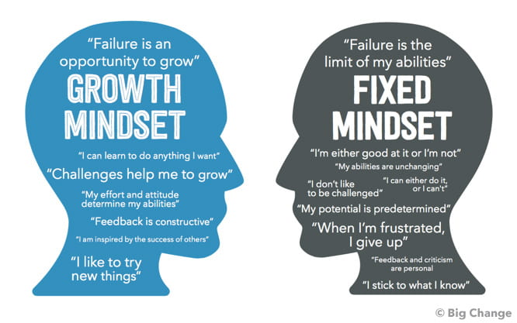

Exercise 1: Self-Care Vision Board
Keywords: Self-care, self-compassion, creativity, inspiration
Time: 60 minutes
Goal: To increase self-compassion through fun and playful creativity.
Self-care is the deliberate practice of activities that take care of mental, emotional, and physical health. The ability to attend to and meet personal needs through self-care has been found to increase empathy and immunologic functioning and has been associated with lower levels of anxiety and depression (Schure, Christopher, & Christopher, 2008).
According to Baker (2003), self-care activities also have the potential to improve self-awareness, self-regulation, coping, and balancing of self and others.
Instructions
Students should think of as many potential self-care activities as possible, making sure only to include activities they would enjoy completing and that fit with their lifestyle and values. For each activity listed, clients should then find inspiring and positive images and brainstorm words and phrases that correspond with their chosen self-care activities.
Students can then assemble their vision board and place it in a prominent, visible location to act as a visual representation that reflects ideas for self-care and as a motivator to improve and implement self-care.

Exercise 2: Positive Reminiscence
Keywords: Savoring, strengths, positive emotions, confidence building
Time: 5-10 minutes
Goal: To help students cultivate positive emotions through savouring.
Savouring is the awareness of pleasure and the ability to acknowledge, appreciate, and enhance positive experiences. A complementary counterpart to coping, Savouring can help students endure negative life experiences (Bryant & Veroff, 2006). When students learn to Savour the small pleasures in life through deliberate focus, they begin to recognize and retain the good feelings associated with those experiences.
The Positive Reminiscence exercise can help students develop the skill of savouring and building positive emotions by reliving a positive event from their past.
Instructions
During the exercise, students should take time to think about an event from their past that evokes positive emotions, visualize the event in as much detail as possible, and focus on the pleasant feelings that were experienced at the time. The student's focus should be on reliving the experience to increase both the duration and intensity of positive emotions.

Exercise 3: The Guest House Poem
Keywords: Acceptance, negative emotions, mindfulness, emotional intelligence
Time: 30 minutes
Goal: To emphasize that emotions are fleeting, and even unpleasant emotions can have value.
The Guest House poem is a method of explaining mindfulness and the importance of acknowledging and accepting unpleasant emotions. According to
Eisenberg et al. (1997), emotion suppression has been associated with both psychological and physiological health detriment.
Indeed, Hayes, Pistorello, & Levin (2012) suggested that attempts to control uncomfortable thoughts, feelings, and emotions by deliberate avoidance are at the core of many psychological problems.
When students mask their emotional experiences or try to push unpleasant emotions away, they can return amplified. However, by welcoming them as visitors, the intensity and impact of those emotions can be reduced. In the poem, being human is like being a guest house, and emotions are personified as temporary visitors that should be welcomed even if they are unpleasant.
The poem can also be used to explain to students that emotions are not permanent residents in their guest house; instead, they are transient visitors who can be welcomed, stay for a while, and then leave.
The Guest House by Jelaluddin Rumi
This being human is a guest house.
Every morning a new arrival.
A joy, a depression, some momentary awareness comes as an unexpected visitor.
Welcome and entertain them all!
Even if they are a crowd of sorrows, who violently sweep your house empty of its furniture,
still, treat each guest honourably.
He may be clearing you out for some new delight.
The dark thought, the shame, the malice.
Meet them at the door laughing and invite them in.
Be grateful for whatever comes.
Because each has been sent as a guide from beyond.

Ask yourself:
- How do you interpret the poem?
- What emotions visit you most often? Why do you think that is?
- How might it affect you if you welcomed all your feelings rather than denying them?
- What benefits could there be in holding unpleasant emotions?
- How might you apply the message of The Guest House to your everyday life?

Exercise 4: Strengths & Values-based Introductions
Keywords: Communication, values, strengths, team-building
Time: 10 minutes per student
Goal: To introduce students to each other in a meaningful way by sharing information about their strengths and values.
The Strengths & Values-based Introductions exercise can act as a motivator and builder of trust among group members, providing students with an opportunity to get to know one another deeply in a short amount of time.
This strengths-based approach allows students to tell and retell their stories and, with the social worker’s guidance, reintegrate parts of the self that might have slipped from their awareness due to cognitive rigidities or relational insecurities (Rashid, 2014).
In this exercise, students are invited to highlight their strengths and values through storytelling and to draw parallels from their stories to their current life situations. In the process, students can develop a deeper understanding of their strengths and values in the context of their narratives.
References

- Arnesen, Smolkowski, Ogden & Melby-Lervåg 2017, Pedagogisk håndbok Kuben vgs 2019.

- Baker, E. K. (2003). Caring for ourselves: A therapist's guide to personal and professional well-being. American Psychological Association. https://doi.org/10.1037/10482-000

- Bechara, P. (2017). ‘Employment polarisation and occupational dynamics’, mimeo, RWI.

- Blackwell, L. S., Trzesniewski, K. H., & Dweck, C. S. (2007). Implicit theories of intelligence predict achievement across an adolescent transition: A longitudinal study and an intervention. Child Development, 78(1), 246-263.

- Bryant, F. B., & Veroff, J. (2007). Savouring: A new model of positive experience. Lawrence Erlbaum Associates Publishers.

- Dweck, Carol S. (2012). Mindset: How you can fulfill your potential. London.

- Handbook of competence and motivation. Elliot, Andrew J., Dweck, Carol S. (Pbk. ed.). New York: Guilford Press. 2007.

- Hayes SC, Pistorello J, Levin ME. Acceptance and Commitment Therapy as a Unified Model of Behavior Change. The Counseling Psychologist. 2012;40(7):976-1002. doi:10.1177/0011000012460836

- Heckman, James J. & Kautz, Tim, 2012. "Hard Evidence on Soft Skills," IZA Discussion Papers 6580, Institute of Labor Economics (IZA).

- Mari Rege – lecture at Godalen Vocational College 2. January 2022.

- Spinrad TL, Eisenberg N, Cumberland A, et al. Relation of emotion-related regulation to children's social competence: a longitudinal study. Emotion. 2006;6(3):498-510. doi:10.1037/1528-3542.6.3.498.

- Tayyab Rashid (2015) Positive psychotherapy: A strength-based approach, The Journal of Positive Psychology, 10:1, 25-40, DOI: 10.1080/17439760.2014.920411

- Schure, M. & Christopher, John & Christopher, Suzanne. (2008). Mind-Body Medicine and the Art of Self‐Care: Teaching Mindfulness to Counseling Students Through Yoga, Meditation, and Qigong. Journal of Counseling & Development. 86. 10.1002/j.1556-6678.2008.tb00625.x

4. Appropriate decisions, including choosing career and profession

What is career planning?
Career planning is the process of making decisions about what you want to do with your life and how you’ll accomplish it. It should be an ongoing process that you revisit, especially when you, or the world, have changed.
Career planning may look different for different people. However, a great place to start is considering your skills and values first. With that foundation, you can start exploring which types of jobs and roles align with what you want. Career planning can involve assessment tests, professional coaching, educational programs, and occupational training.

How do you start career planning?
There are four main areas you’ll want to consider. These are your:
- Interests
- Skills.
- Values.
- Preferences.
Interests are the things that you are passionate about. You’d want to spend time (and maybe money) learning more about them.
Ask yourself:
- What would I do in my free time?
- What do I find interesting?
- What would I read a book about or take a class on?
Skills are what you excel at. They can be natural talents, or they may be areas of competency that you’ve developed over time. It may take a little creativity to see where you can turn your interests and skills into career options. For example, if you’re creative and organized, you might like graphic design, social media marketing, or app development.
Ask yourself:
- What am I good at?
- What do I do better than anyone?
- What’s something that I do for free that others get paid to do?
Your values will help shape how you use those talents in the world. Values are the ways in which you want to make a difference. For example, let’s say you want to become a lawyer. Do you want to be a prosecutor, a public defender, general counsel, or specialize in intellectual property? Do you want to work in criminal justice or environmental law? The same job title may find you at very different companies.
Ask yourself:
- What problem am I passionate about solving?
- What makes me really sad, happy, or angry?
- What cause would benefit from my skills and experience?
Finally, imagine your dream day at work. Are you driving to work, biking, walking, or rolling out of bed? Is your dream work environment a big-city skyscraper, or a sunny cafe? Does your work keep you busy, or do you have plenty of time to spend with friends and family? Are you earning a lot of money, or just enough? These preferences will help you decide which career path will best suit you and the work-life balance you desire.
Ask yourself:
- What does my ideal morning look like?
- What’s one thing that’s more important to me than work?
- Where do I want to live?

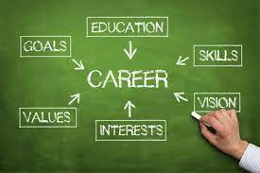
Sources: https://gvicglobal.com/cgi-sys/suspendedpage.cgi

7 steps to organized career planning
When you’re ready to sit down and write (or review) your career plan, follow these 7 steps:
- Self-evaluation is the first step of the career planning process. The questions in the section above are a great way to start. Talking to a coach or a career counselor is also a great way to gain insight into your strengths and where you might thrive. Be sure to take enough time for self-exploration in this first step, or you may find yourself unhappy with your career decisions later on.
- Research your dream job
Do some research and a job search for the title that you want to have. Read the job description, paying close attention to the skills and responsibilities of the position.
- Determine the basic steps
There isn’t one right path to your dream job, but there may be certain steps that are non-negotiable. For example, if you want to become a doctor, you won’t get there without going to medical school. What are the non-negotiable short-term goals for your role, and how do you get there from where you are?
- Identify organizations that align with your values
While you’re researching open roles, look at the companies that are posting the jobs. Are they companies that you could see yourself working for? Which types of organizations appeal to you the most? What kinds of perks, healthcare, and salaries do they offer? For some people, the type of company might be more important to them than their own title or role. For others, the industry or the organization’s mission might be more important than. Ask yourself what matters to you and why.
- Look at job openings on the ground level
Once you’ve gotten an idea of what role and which companies you’re working towards, look at other roles in the same department. What’s the easiest rung on the ladder for you to grab? It might be an entry level position on the help desk — or it might be a coordinator or other mid-level role.
- Take the next right step
Identify which short-term goals get you closer to the job that you want. If it represents a career change, you may want to start by applying to training or graduate school. If it’s just the next step in a field you’re already in, you may just have to start sending out your CV. If you love the company you’re with but you’re ready for a new role, discuss your goals with your manager. They can help you create a career development plan and start taking on new responsibilities.
- Tell everyone you know
The final step of the career planning process is to recruit as much help as possible. Tell your manager, coach, and everyone that you’re looking to move ahead. Networking and showing your commitment to growth is a critical part of your career planning development.

Career Plan

What is a career plan?
A career plan is a practical strategy that allows you to determine your skills and interests, set career goals, and put actions in place that will help you reach them.
It’s a continuous process, and it includes an overview of:
- Your current skills and experience
- Your career goals
- Your interests
- Your priorities
- Your intended actions

Why is career planning important?
Career planning is a great way to ensure your career is going in the right direction.
Not only does it help you realise your passion, it also facilitates your career goals with tangible actions and aims. At the very least, it’ll help you to answer career goal questions at your next interview.
By assessing your situation, you’ll additionally be able to determine and fill any gaps in your knowledge or experience that might be holding you back from your dream job.

Who should make a career plan?
Everyone can benefit from creating a career plan.
Career plans can be laid out in many ways, depending on how specific you want to be with your goals – and what you want to place precedence on achieving.
However, your career planner should always follow a clear and easy-to-read format.
To point you in the right direction, here’s our career plan example:

Personal overview
Include a brief outline of who you are and what you’re looking for. Include your strongest attributes and interests, as well as where you’re at in your current situation.
Education
Provide an overview of your educational qualifications.
Employment history
Write a short summary of your employment history.
Goals
Short term: E.g. secure job with progression opportunities (in 6 months).
Mid-term: E.g. get a promotion (in 2-5 years).
Long term: E.g. become head of department (in 5+ years).
Current skills, knowledge, and experience
Sum up your key skills and competencies – whether they’re gained from work, study, or hobbies.
Training and development requirements
Use this section to assess what training and development is needed to achieve your goals.
Action plan
Give yourself a clear, step-by-step guide of the actions needed to reach your goals – including timescales against each action.
You can include as many actions as you want, but it might be most useful to limit yourself to a smaller number – so you can add new ones as you progress.

How to write good CV?
CV – curriculum vitae means "course of life" in Latin. A CV is a concise document which summarizes your past, existing professional skills, proficiency and experiences. The purpose of this document is to demonstrate that you have the necessary skills (and some complementary ones) to do the job for which you are applying. Literally you are selling your talents, skills, proficiencies etc.

Writing a good CV can be one of the toughest challenges of job seeking (samples of good and bad CVs are in the Annexes).

Most employers spend just a few seconds scanning each CV before sticking it in the 'Yes' or 'No'
- Know general information for CV: your personal information, your education and qualifications, your work experience, your interests and achievements, your skills, and references.
- Consider the job you are applying for. A good CV is tailored to the specific job and company you are applying for.
- Check the company’s website for extra information for your CV.
- Make a list of jobs you have held.
- Brainstorm your hobbies and interests. Reading can be good hobby, if you applying for a job at a publishing house or library
- Make a list of your relevant skills. These skills often include computing skills, languages you speak, or specific things the company is looking for, such as targeted skills.
- Check your spelling and grammar.
- Read your CV as if you were the company you are applying to.
- Get someone else to read your CV.

Activity 1
“High quality and non-quality CV”
Time – 1 hour
Aim - to develop the ability to determine qualitative cv criteria
Proceeds:
Divide students in to groups (4 students in each). Give to each group CV example (ANEX I) and ask them to correct the mistakes. Instruction for students: “Read this CV, found main mistakes and please specify how to correct them”. After group leader must present discussions result.

Questions for analysis:
- Who indicates CV quality?
- What must be reflected in to CV?
- What information in not unnecessary for CV?
- If you would be staff manager, to what points you will pay attention?
- What are main mistakes in CV?
- What are requirements for “excellent” CV?

Activity 2

“Preparing motivation letter”

Time – 1 hour
Aim - to develop students ability write motivation letter.
Proceeds:
Divide students in to groups (4 students in each). Give to each group job offer example (handouts) and ask them to write motivation letter. Instruction for students: “Read this job offer and write motivation letter. Main aim of this letter - be invited to a job interview”. After group leader must present motivation letter to all class.

Questions for analysis:
- What was most difficulty in writing process?
- Which letter is most suggestive?
- What information in not unnecessary in motivation letter?
- In which way motivation letter can be improved?

Activity 3

„The elevator pitch “

The reason it's called an elevator speech is because you should be able to present it during a brief elevator ride. Done right, this short speech helps you introduce yourself to career connections in a compelling way.
This speech is all about you: who you are, what you do, and what you want to do (if you're job hunting). Your elevator pitch is a way to share your expertise and credentials quickly and effectively with people who don't know you.
Time – 1 hour
Aim - to develop students ability present themselves in a short time.
Proceeds: Students divided in to 2 groups: job seekers and personal managers. Job seeker must present himself for job manager in 45 seconds, until the elevator rises. After manager have 2 minutes to discuss and say comments.
After 20 minutes you must change positions and start again.
After game students will discuss about game

HANDOUTS FOR ACTIVITY 1

Examples of good and bad CVs

Bad CV example
Curriculum Vitae
Name: Jonesy (Steve)
Address: 99 Long Road Chesterfield England CH68 1PP
Telephone: 0111 333 555
Date of Birth: 26 August 1994
Hobbies: Five a side football, golf and guitar
Work Experience: 2011-2013 Paper boy. Deliver newspapers
Education: 2007-2013 Secondary school

Good CV example
Steven Jones
99 Long Road Chesterfield England CH68 1PP
Tel: 0111 333 555
E: steven.jones@gaggle.co.uk
An excellent communicator with experience in a customer service role. Proven to work well as part of a team as well as on individual assignments. Looking to expand on these skills via a customer facing role in the retail sector.

Work experience
June 2011 – Present
Paper delivery assistant: Smith Newsagents, Chesterfield
- Bi-weekly newspaper delivery round
- Liaised with senior staff to ensure route efficiency for deliveries
- Regular face to face contact with customers
- Completed daily log of enquiries so that order information could be updated
- Updated customer details database to improve information quality

Work experience placement: Topman, Chesterfield
- Two weeks work experience placement, involving customer contact and care of stock
- Greeted customers and assisted with face to face enquiries regarding sizing and availability of products
- Served customers, operating the till and handling money and card payments
- Worked with permanent members of staff on the monthly stock check, with sole responsibility for the accurate log of men’s footwear.
- Assisted with the general upkeep and appearance of the store

Education
September 2008 – Present
Chesterfield Comprehensive Secondary School & Sixth Form
A-Levels: Grades pending, August 2014 Business Studies, English, Maths, General Studies

GCSE’s: August 2012
English (B), English Language (C), Math (C), Science - double award (BB), Information Technology (A), Business Studies (A), History (C), French (B), Music (C), Graphic Design (C)

Key skills & achievements
- Microsoft Word, Powerpoint, Excel and Outlook
- Captain of Riverside under-18’s five-a-side football team – including organising weekly team games and mentoring junior members
- Achieved Grade 5 in electric guitar
- French – basic conversational

Interests
I enjoy football and as well as captaining my local five-a-side team I am a member of the School Sixth Form football team and Sheffield United supporters club. I have a keen interest in music, and as well as playing guitar I regularly attend local concerts. I am also a member of the school music society and have participated in a number of school performances.

References
Available on request

HANDOUTS FOR ACTIVITY 2
Job offers

Human Resources Lead
Responsibilities
- Develop strategies and policies to facilitate the HR/LR activities for the project
- Oversee the onboarding process for all crafts and non-unionized staff
- Lead and manage parent company to deliver on recruitment needs for the JV
- Participate in recruitment activities where needed
- Develop and support employee and industrial relations and communications strategies
- Develop and implement policies/procedures and processes to efficiently manage the human resources and labour relations functions for the project
- Work to deliver on commitments made in the project agreement
- Maintain a pulse on employee and labour relations and provide recommended actions to Project Management to maintain a positive morale
- Apply knowledge of employment legislation, the applicable collective agreement(s) and government reporting regulations affecting HR/LR functions and ensure policies, procedures, and reporting are in compliance
- Manage conflicts, working closely with management to ensure employee and labour relations issues are handled in a professional and timely manner
- Perform case management and investigations
- Coach managers and employees as required
- Work closely with union representatives to work through craft disciplinary issues
- Provide expertise on contract interpretation related to collective agreements
- Manage grievances, attend meetings, track progress and draft responses
- Manage the accurate filing of contracts and employee management data
- Demonstrate a commitment to a safe and respectful work environment
- Understands and support the safety and environmental objectives of the organization
- Perform other administrative duties as required
Qualifications
- Degree in Human Resources, Industrial Relations, Organizational Development or a related discipline
- 7 to 10 years of Human Resources work experience
- At least 5 years labour relations experience
- Experience working on a complex, fast-paced construction project where multiple stakeholders are involved
- Experience with LMIA and C10 immigration and international hiring would be considered an asset
- Demonstrated ability to deal with unions and collective agreements
- General knowledge of the business environment and relevant processes, organization design, change management, systems and procedures
- Demonstrated ability to build strategy, plan for the short and long term and conduct a business analysis
- Excellent interpersonal and conflict resolution skills
- Ability to build rapport with multiple stakeholder partners and clients
- Ability to exercise confidentiality, discretion and tact when dealing with sensitive employment matters
- Exceptional communication skills, both verbal and written

Evaluation

Evaluate your abilities from 1 to 10 points. 1 - I'm completely unable to... 10 – perfectly able to....

 | Skills | Evaluation
 | I am able to evaluate the requirements indicated in the job ad
 | I can identify for employer necessary competencies and present them in CV
 | I am able to use CV and motivation letter as own delivery tool
 | I am able prepare good CV and motivation letter

References:

- https://www.entrepreneur.com/article/270338
- https://smallbusiness.chron.com/importance-culture-organizations-22203.html
- https://www.globalme.net/blog/create-maintain-healthy-work-culture
- https://www.tekna.no/en/career/work-culture/
- https://www.quora.com/How-is-the-working-culture-in-Lithuania-different-from-Western-Europe
- https://www.thebalancecareers.com/top-strategies-for-a-successful-job-search-2060714
- https://www.themuse.com/advice/6-gamechanging-job-search-strategies
- https://www.thebalancecareers.com/targeted-cover-letter-writing-tips-2060176
- https://www.reed.co.uk/career-advice/how-to-write-a-cv/
- https://www.youtube.com/watch?v=AbA3YWBuWXA https://www.youtube.com/watch?v=rGwN_PIooas https://www.youtube.com/watch?v=Uwybsq4OkY4
- https://www.youtube.com/watch?v=jHg0b7Nai6c
- https://www.youtube.com/watch?v=kdUafTx82OM
- https://www.youtube.com/watch?v=UEioCkY0E3Y
- https://www.youtube.com/watch?v=JrbnTZPjg0k
- https://www.youtube.com/watch?v=hQxaxt2hrk8
- https://www.youtube.com/watch?v=Dr1O2lzD6nI
- https://www.youtube.com/watch?v=S1ucmfPOBV8
- https://www.youtube.com/watch?v=t0fM8sCZZes
- https://www.youtube.com/watch?v=I8emh3KK_Bg
- https://www.youtube.com/watch?v=S1ucmfPOBV8
- 7 body language tips to impress at your next job interview: https://www.youtube.com/watch?v=PCWVi5pAa30
- https://www.reed.co.uk/career-advice/how-to-write-a-cv/
21.https://www.reed.co.uk/career-advice/cvs/

5. Effective communication

«Communication is inevitable. Non-communication doesn’t exist, any type of human manifestation represents an act of communication».
The Palo Alto Group (1976)

We are all part of a certain social reality. In this ambience we not only meet objects, things, symbols, but other human beings, institutions, social and moral values. The human behavioural response to these stimuli is a mentally regulated behaviour, which manifests in a social framework where the behaviour of an individual meets another’s. In the setting of this interconnection an adaptive process takes place from an individual to another. This trains a behavioural reciprocity which then determines an implication between the two. In this social framework of human behaviour, we mention the importance of three factors:

- The psycho-individual peculiarities of individuals.
- The contact history of individuals with peers.
- The context of meeting and interaction between people.

The implications that are established between behaviours are clarified by the concept of interpersonal relationship – “connection in the form of the perception, understanding, evaluation and likeability of one person by another person.” (Popovici, D., V., 2000).

Within interpersonal relationships we can distinguish:
  - Functional relationships, specific in interaction oriented towards joint task solving;
  - Intercommunication relationships, specific to psychosocial interaction;
  - Inter-cognitive relationships, specific to formal learning, research institutions and professional environments;
  - Inter-affective relationships, in a preferential, sociometric system.
All types of interpersonal relationships need to use language and communication as fundamental tools.

All definitions of communication cannot integrate all of its meaning in an exhaustive manner. Human communication occupies a multitude of areas: linguistic, psychological, philosophical, mathematical, educational, psychosocial etc. Communication is a difficult and complex process and therefore hard to define. Communicating can mean making known, informing, conveying, notifying, saying; (about people, social communities, etc.) being in touch with, talking to (dictionary).

Social psychology defines human communication as a “fundamental way of psychosocial interaction of people, achieved through the symbols and social-generalised meanings of reality, in order to obtain changes in individual or group behaviour” (Social Psychology Dictionary, 1981).

This definition reveals the essence of human connections – communication is the process through which social relationships take place and develop, operating as a regulating and self-regulating mechanism in the space of social contacts. We deduce from this that any qualitative change in the act of communication will have a direct proportional impact on the relationship between communicators, which is why the intense concern for improving the ability to communicate has led to the emergence of theories about effective communication, nonviolent communication, the pragmatic dimension of communication, active listening, assertive communication, positive communication and much more.

«Communication is power. All behaviour and feelings find their original roots in some form of communication».
Tony Robbins
The aforementioned definition from the field of social psychology is based on the study of philosophers Charles Morris (1938) and Rudolf Carnap (1942), who outlined three main areas in human communication (Paul Watzlawick, Janet Beavin Bavelas and Don D. Jackson, 2014):

- Syntactic – the field that deals with the case of information transmission, being interested in coding, communication channels, redundant, noise and any other statistical property of language.

- Semantic– the field concerned with the meaning of the symbols that make up the message and which refers to the meaning agreed by the sender and receiver on the string of communicated symbols.
- Pragmatic - the field concerned with the psychological dimension of communication and its influence on human behaviour.

Whilst on a conceptual level all three areas can be separated, they are constantly in an interdependent relationship. If from a syntactic point of view the exact transmission of a series of symbols is perfectly possible, they will be empty of content as long as the sender and receiver have not agreed on their meaning, and from the latter semantic complicity derives the most fabulous of the properties of communication, that of behaviour modification.

In a pragmatical sense, communication can be seen as a circular system in which the relationship between communicators is one of determination, a mutual influence. This insight has determined the emergence of the concept of feedback, first in cybernetics in 1948, and later on adopted by the social and financial systems, now being an institutionalised tool in education and in the corporate environment. Considered to be positive or negative, the mission of feedback is extremely useful for streamlining communication between individuals. Positive feedback from communicators confirms the inclination toward the implicit change proposed in the communication input and is therefore constructive, while negative feedback can filter, limit or cancel the interaction.

Source: https://www.clipartkey.com/view/hTxbww_clip-art-effective-communication-clipart-effective-communication-clipart/

Offering the right feedback with the right intentions is a skill and, like all skills, it takes practice to acquire it. Effective and constructive feedback:

  - has the PURPOSE to improve performance and not to criticise or offend the recipient;
  - is formulated in a POSITIVE manner;
  - is CORRECT and BALANCED; good feedback is not exclusively laudatory, but includes recommendations for improvement;
  - is offered AT THE RIGHT TIME, neither delayed nor hastened; feedback is effective when covering recent time periods;
  - is used CONSTANTLY, it is not an annual or quarterly event;
  - it is SPECIFIC, conveying exactly what needs to be improved, without ambiguity.

«The single biggest problem in communication is the illusion that it has taken place».
George Bernard Shaw
How well do you communicate? Being able to provide clear, accurate, relevant information is an essential skill for personal and social autonomy. Most of us have experienced communication difficulties at least once: we felt misunderstood, we were so absorbed in our own monologue that we forgot to connect with the interlocutor, we hesitated to express our emotions or opinion, we were embarrassed to ask for clarification of the message received, we did not listen or understand someone else’s point of view.

The most common barriers to effective communication are often:

- Stress and intense emotions – when we are stressed or emotionally overwhelmed, the likelihood of “misreading” others or non-verbal language disagreeing with verbal language is higher. It is very important to be aware and in control of our emotions, as well as to offer them with speech, because the non-verbal and para-verbal indicators associated with the emotion will reach the interlocutor before the verbal message, damaging it.

- Concentration difficulties – when we carry out several activities at the same time, we surf the phone or think about the answer we are going to deliver, we lose sight of information as well as non-verbal cues transmitted by the interlocutor. Effective communication involves focusing and avoiding distractors.

- Inconsistent non-verbal language – non-verbal communication should amplify, not contradict, what is being said. The message becomes confusing and unbelievable. Speaking of which, isn't it hard to nod YES and say NO at the same time? Approaches an open body posture, with arms uncrossed and eye contact sustained.

- Negative body language – you may not agree with what is being said and reject what you hear by avoiding eye contact, using facial expressions of disagreement, distractibility. Communicating effectively means being aware that all these signals do not improve the interlocutor's speech but make him anxious and defensive.

«Listen with the intent to understand, not the intent to reply».
Stephen Covey
Effective communication intersects the ability to be a good listener. The origins of the concept of active communication are found in the humanistic theory of Carl Rogers (1957), a person-centred theory and its ability to communicate authentically and self-reveal.

Active, as opposed to passive, listening has been described as a process that includes strategies such as commenting, asking questions, paraphrasing, and summarizing (Thomas Gordon, Noel Burch, 2003 and David McNaughton, Dawn Hamlin, John McCarthy, Derlene Head-Reeves, Mary Schreiner, 2008) supported by maintaining eye contact, using non-verbal language of encouragement, not interrupting the speaker (Kathryn Roberston, 2005), actions that lead to a better understanding of the message received.

It is important to note here that active listening is in itself an effective act of communication, through which the listener communicates his interest in the speaker's message and works with him to build common sense.

The term "active listening" has been used for more than 60 years in multiple fields: psychotherapy, mediation, corporate, medical services, sales and crisis management, as well as negotiation with hostages. As a result, countless scales have been created to assess this aptitude: Active Listening Attitude Scale (ALAS), (Norio Mishima, Shinya Kubota, Shoji Nagata, 2000) Active-Empathic Listening Scale (AELS), (Drollinger et al, 2006 și Graham Bodie, 2011), Active Listening Self-Assessment (Harvard Business School, 2004), Effective Listening and Interactive Communication Scale (ELICS), (Gillian King, 2011), The Daily Listening Scorecard (https://www.listeningpays.com/ , 2014) etc.

Research suggests that we can remember between 25% and 50% of what we hear. That is, when we speak, at most half of what we say is received. A unique technique for amplifying the ability to listen is to orient our right ear in the direction of the speaker. Oddly enough, the left side of the brain, which is connected to the right side of the body, is the one that houses the processing centres of both language and emotions, so favouring the right ear in the act of active listening leads to improved comprehension of the cognitive and emotional message of the speaker.

Source: https://www.clipartkey.com/view/iixTob_communication-clipart-basic-communication-animated-png-clip-art/

«Communication must be HOT. That’s Honest, Open and Two-way».
Dan Oswald

The way we communicate is unique. Each of us has a dominant style of communication and its predominant use validates our belief that our message will be conveyed effectively. Some situations will require certain styles, and some of our interlocutors will be more receptive to one or the other. Although some styles are more effective than others, we will not be able to use them exclusively but will combine or alternate some of the following 5 communication styles identified:
1. Aggressive.
2. Passive / submissive.
3. Assertive.
4. Passive-aggressive.
5. Manipulative.

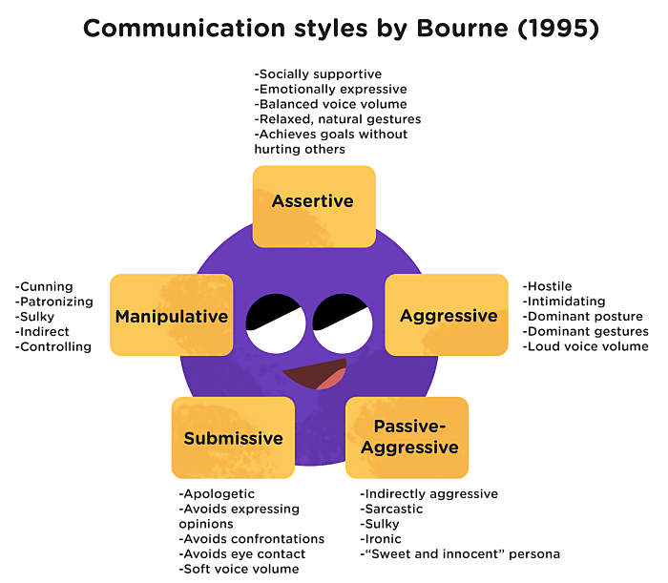
Source: https://pumble.com/learn/communication/communication-styles/

The diagram above briefly shows the efficiency of using assertive communication. It is defined as “the ability to speak and interact in a manner that considers and respects the rights and opinions of others while also standing up for your rights, needs, and personal boundaries” (Pipas & Jaradat, 2010). In other words, the one who communicates assertively expresses his needs in a direct, calm and reasonable way with confidence, taking into account at the same time the needs of the interlocutor.

Who is the assertive communicator?

Pipas and Jaradat (2010), and then Bishop (2013) list the following features https://www.berkeleywellbeing.com/assertive-communication.html:
- maintains eye contact with the interlocutor, communicating that he does not feel intimidated;
- his body position is assertive, balanced between looking too weak and too aggressive;
- has a strong vocal tone, but not aggressive;
- facial expression expresses neither anger nor anxiety;
- communicates at the right time;
- expresses needs clearly;
- is non-threatening, communicates without blaming or threatening the interlocutor, assuming his own feelings and behaviours, by initiating statements in the first person, "I";
- formulates messages in a positive way;
- he is neither critical nor self-critical.

Assertive communication is the ideal style of communication because it is the healthiest style of communication. Assertive communicators express their needs in a respectful manner, listen without interruption, use sustained eye contact, use a calm tone, speak clearly, and do not allow others to manipulate or abuse them.

Who is the passive communicator?

The passive communicator puts his needs and feelings in the last place. He feels uncomfortable expressing himself and allows others to do so, which can lead to misunderstandings, the accumulation of feelings of anger and resentment. They are the ones who avoid eye contact, find it difficult to refuse a request, have an insecure posture, and avoid conflicts. Passive communicators are non-disturbing interlocutors, people-pleasers, they tend to take a step back and let other people, more assertive or aggressive, lead. The passive must be trained to express their ideas, to access a more assertive style, otherwise their contribution and valuable ideas will remain in the shadow.

Who is the aggressive communicator?

In contrast to the passive style, aggressive communicators put their needs and feelings first and reject, ignore or insult the needs and feelings of others. They are either hostile or defensive when confronted, tend to speak loudly, have a demanding tone, make demands, and ask accusatory questions. The aggressive communicator is not a good listener, he behaves as if his contribution to the conversation is more important than anyone else's and uses offensive statements in the second person, "you". Due to the fact that the form of his message takes on an unpleasant nuance, it is rejected by the listener and it is recommended to avoid it in any of the conversational environments in which we operate. The dialogue with such a speaker is unpleasant, minimising, intimidating and the use of this style has been observed especially in the business environment, in some managers.

Who is the passive-aggressive communicator?

As the name suggests, this style combines elements of aggressive and passive communication styles. Appearance is passive, while the aggressive is the one who boils underneath. The passive-aggressive person wears the coat of the gentle and understanding interlocutor, but inside they feel angry and full of resentment. His speech is sprinkled with negative statements, sarcasm, condescending remarks, gossip, indirect ways that bring to the surface the frustration he felt. It is a very toxic and disruptive communication style, which creates confusion and discomfort, the aggressive message being implicit and not explicit.

Who is the manipulative communicator?

This style of communication uses mystification, cunning, and influence to control the interlocutor and the outcome of the conversation with him. The manipulator rarely says what he wants to say and hides his real goals. He will disturb the waters so that his true intentions will not be known until their goals are reached - and perhaps not even then.

Like assertive communicators, manipulators know what they want and how to achieve this, but they try to achieve their goals by fooling people, instead of speaking directly and honestly to them. They often make use of techniques such as to obscure, to argue emotionally, to derail from the topic of discussion. The dialogue with a manipulator requires our vigilance, as they try to sneak their own agenda into the conversation.

As with aggressive and passive-aggressive styles, manipulators must be guided towards an assertive communication style. Rephrase what they are trying to say to show how you would prefer them to communicate. What would it sound like if they expressed their opinion directly and assertively?

«While we may not consider the way we talk to be ‘violent’, words often lead to hurt and pain, whether for others or ourselves».
Marshall B. Rosenberg

Along with assertive communication, one of the most popular models of communication is non-violent communication (NVC). Developed by clinical psychologist Marshall B. Rosenberg in the 1960s and 1970s, this approach to communication aims to increase the level of empathy and improve the quality of life of those who use it and the recipients of this approach. NVC is at the same time a popular technique in psychotherapy, as well as a tool for personal development in terms of seeking harmony in all the media in which we operate, whether formal or informal.

If criticising, accusing, discriminating, minimising, judging, isolating would be elements of violent language, nonviolence, according to Rosenberg, involves the integration of the following 4 dimensions:

1. The observation. It represents the initial stage of nonviolent communication and allows us to gather information about the way the interlocutor behaves and speaks, about his needs, communicated implicitly or explicitly, without the intervention of judgement and evaluation.

2. The feeling. The second stage of NVC refers to the awareness of one's own feelings generated by the behaviour and speech observed in the interlocutor.

3. Identifying one's own needs. In this phase it is necessary to internally formulate the needs related to the communicator in front of us: we appreciate what he says, we feel comfortable in his presence, we want to change his tone or not.

4. Specific request. It is the stage in which we convey to the other what the identified or unfulfilled needs are identified, taking into account the way he feels in relation to our requirements.

The non-violent communication model leads to the interaction between people in an area of optimal functioning. By directly stating needs, the relationship takes on a subjective dimension, strengthening our fundamental need to form and develop strong emotional bonds with those around us.

Effective communication strategies in the virtual environment

The social web and more recently, due to the recent pandemic context, information and computer technology training, the virtuous method of which is Computer-supported collaborative learning (CSCL), are contemporary areas that occupy a significant place in today's human activity.

Technology-mediated communication has become an essential part of our interactional lives. The favoured way of interaction is represented by the web communities, which take various forms: social network, forum, chat, blog, web page, e-mail, etc. Their advantages are real: they are fast, accessible, dynamic, collaborative, allow the use of various multimedia tools, and communication can take place synchronously or asynchronously, at your own pace. However, virtual communication also has its disadvantages: the ambiguity of language, polyphony (Mihail Bahtin, 1970) - the appearance of several voices, which may be temporarily dissonant or threads in parallel, the difficulty of transmitting the non- verbal and paraverbal of the message.

Since literature and love correspondence demonstrate an incredible capacity to sustain interpersonal emotional exchange, text-based virtual communication could not be considered emotionally flat. The problem of effective communication and measurement of emotional processes mediated by technology does not arise, however, in informal environments but especially in formal ones (professional, educational).

Emotions are a mode of communication (K. Oatley, 1999), they are the catalyst for interpersonal relationships, they are essential to the functioning of the mechanisms of will and motivation, they are authentic and difficult to disguise because they operate at an unconscious level, they are essential in the communication of personal identity (J.B. Whalter, 1996).

The studies by Rourke et al. (1999) and Anderson et al. (2001) are among the few to investigate the content of text messages and their ability to convey emotion. Analysing the contents of communication on University of Alberta student discussion forums, Rourke et al. (1999) identify 12 indicators of social and affective presence, which they group into three categories: affectivity, interactivity, and cohesion. Thus, according to the authors, the degree of presence of a participant in the online communication process can be analysed along three dimensions, to which we will add examples of specific, novel strategies of virtual communication:

- Affective presence: the participant expresses emotions, feelings and affective mood through strategies such as: self-disclosure, use of humour, direct/conventional expression or through the conventions of technology-mediated dialogue (repetition of punctuation, excessive use of capital letters, emoticons, character combinations);
- Interactivity: continuing a discussion thread, quoting, asking questions, expressing agreement, using appreciation, through strategies such as: using reply, forward, copy, paste software facilities;
- Cohesion: the participant provides responses that build and maintain a sense of belonging and commitment to the goals and objectives of the group through strategies such as: use of the vocative (addressing participants by name), use of the inclusive pronoun (we, us, ours), use of the opening and/or closing greeting.

Technology-mediated modes of communication are new and constantly developing, so we could call it an alternative language. Users are inventive, emoticons are varied, all of which reinforce the obvious human need to communicate as effectively as possible, a mechanism motivated by the tendency to reduce uncertainty and anticipate the behaviour of the other party.

References:

1.Gordon, Thomas, Burch, Noel “Teacher Effectiveness Training: The Program Proven to Help Teachers Bring Out the Best in Students of All Ages”, Three Rivers Press, New York (2003) [Google Scholar].

2. Roberston, Kathryn “Active listening: More than just paying attention” Australian Family Physician 34 (2005).

3. Rogers, Carl R. “The necessary and sufficient conditions of therapeutic personality change”, Journal of Consulting Psychology 21 (1957) [Google Scholar].

4. Rogers, Carl R., Farson, Richard E. “Active listening” Organizational Psychology (1979) [Google Scholar].

5. Rosenberg, Marshall B. “Comunicarea nonviolentă”, Editura Ponte, București (2014).

6. Traușan-Matu, Ștefan, editor “Interacțiunea conversațională în sistemele colaborative pe Web”, Editura Matrix Rom, București (2008).

7. Watzlawick, Paul, Beavin Bavelas, Janet, Jackson, Don D. “Comunicarea umană. Pragmatică, paradox și patologie”, Editura Trei, București (2014).

8.Walther, J.B., Loh, T., Granka, M. “Let me count the ways: The interchange of verbal and nonverbal cues in computer-mediated and face-to-face affinity”, Journal of Language and Social Psychology, 24 (2005).

9.Walther, J.B. “Interpersonal effects in computer-mediated interaction: A relational perspective” Communication Research, 19 (1992).

10.https://media.healthdirect.org.au/publications/CarerGateway_Resource_02_Effective_communication_techniques_v03.pdf

11.https://www.berkeleywellbeing.com/assertive-communication.html

12. https://www.mindtools.com/pages/article/newTMM_98.htm

13. https://www.helpguide.org/articles/relationships-communication/effective-communication.htm

14. https://www.art-educational.ro/info/blogitem/comunicarea-nonviolenta-modalitate-de-comunicare-eficienta

6. Learning effectively for daily classes, exams, successful career and a fulfilling life

Everyday learning and exams are part of school life for kids and to do this job in the right way and at the right time is very important for the preventing burnout. All knows that effective learning is basic thing for the future successful career and fulfilling life. The knowledge and skills for the well-organised learning process help to avoid stress and feel self-confident and happy at school and private life.
Studying smart and learning faster lies mostly in you personally. It is about how you study and how you manage yourself. With the right mindset and right purpose, you will manage yourself to greater success in life.
Create the best environment for learning
To be productive in studying for daily classes and exams and to learn faster, many students would prefer a conducive environment – relatively quiet and in comfort. You would need all these to stay in-focus. Focus on what you are studying, is of essential for success. Your mind must be in sync with the physical surroundings for it to be at its best.
It is very important to organize daily learning process. Maybe you can’t control your school routine, but you can always control how and where you do your homework. Why not attend your Zoom calls at a coffee shop, bookstore, your friend’s apartment, or even your favorite outdoor spot? Change your scenery and move to a different room or outside.
Know your learning style
Most of us have three dominant ways of learning. Learning aids should support preferred way of learning. If you are a Visual person, you tend to learn through the use of images and videos.
You could also be an Auditory person. An auditory person likes to listen. Background music, audio recording of lectures and videos with excellent audio would probably be a great help.
Lastly, if you are a Kinesthetic person, you are strong with your feelings. Your learning aids may have different textured papers and models in which you could create the sensation of touch. Therefore, different learning aids have different impact to preferred mode of learning.
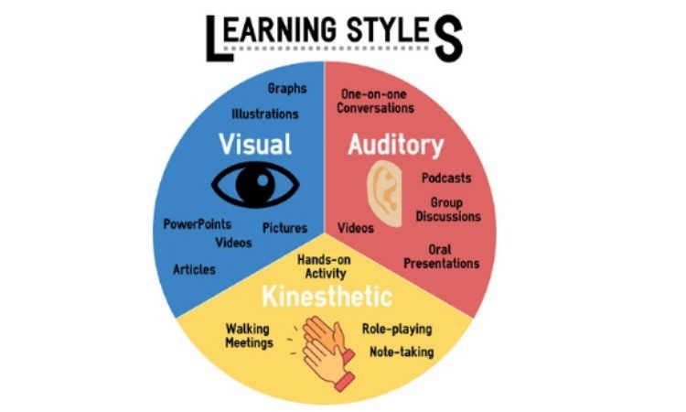 Source:https://turningpointcentre.com/identifying-your-learning-style.html
David Kolb's Learning Style
The learning cycle that David Kolb analysed in his model published in 1984 involves four stages, namely: concrete learning, reflective observation, abstract conceptualization and active experimentation.
Effective learning can be seen when the learner progresses through the cycle. You as the learner can enter the cycle at any stage of the cycle with logical sequence.
The first stage is concrete learning or concrete experience, where the learner encounters a new experience or reinterprets an existing experience.
This could be where the learner is exposed to a new task or a new way of carrying out a project, in a way they haven’t seen before.
This is followed by the next stage, reflective observation, where the learner reflects on the experience on a personal basis.
For many people, this is where the metamorphosis from seeing and doing to reflecting can embed the learning into real-time absorption of materials and methodology.
It could be where a person is shown how to accomplish a goal and then looks at how it could be applied in differing circumstances.
Following reflective observation is abstract conceptualisation, where learners form new ideas, or modify current abstract ideas, based on the reflections that arise from the reflective observation stage.
They now have the chance to see how the ideas learned previously can be applied in their real world. The concepts they see can be altered by the results they have seen obtained in observing the ideas formulated in previous stages.
Then, there’s the active experimentation stage.
This is where the learner applies the new ideas to her surroundings to see if there are any modifications in the next appearance of the experience.
By actively experimenting with the whole concept of visible action, we learn to associate what we have experienced with new ideas and innovations.
This second experience becomes the concrete experience for the beginning of the next cycle, beginning at the first stage, and this process can happen over a short or long time.
Kolb takes these four components and builds on them to create four overall learning dimensions, as listed below:
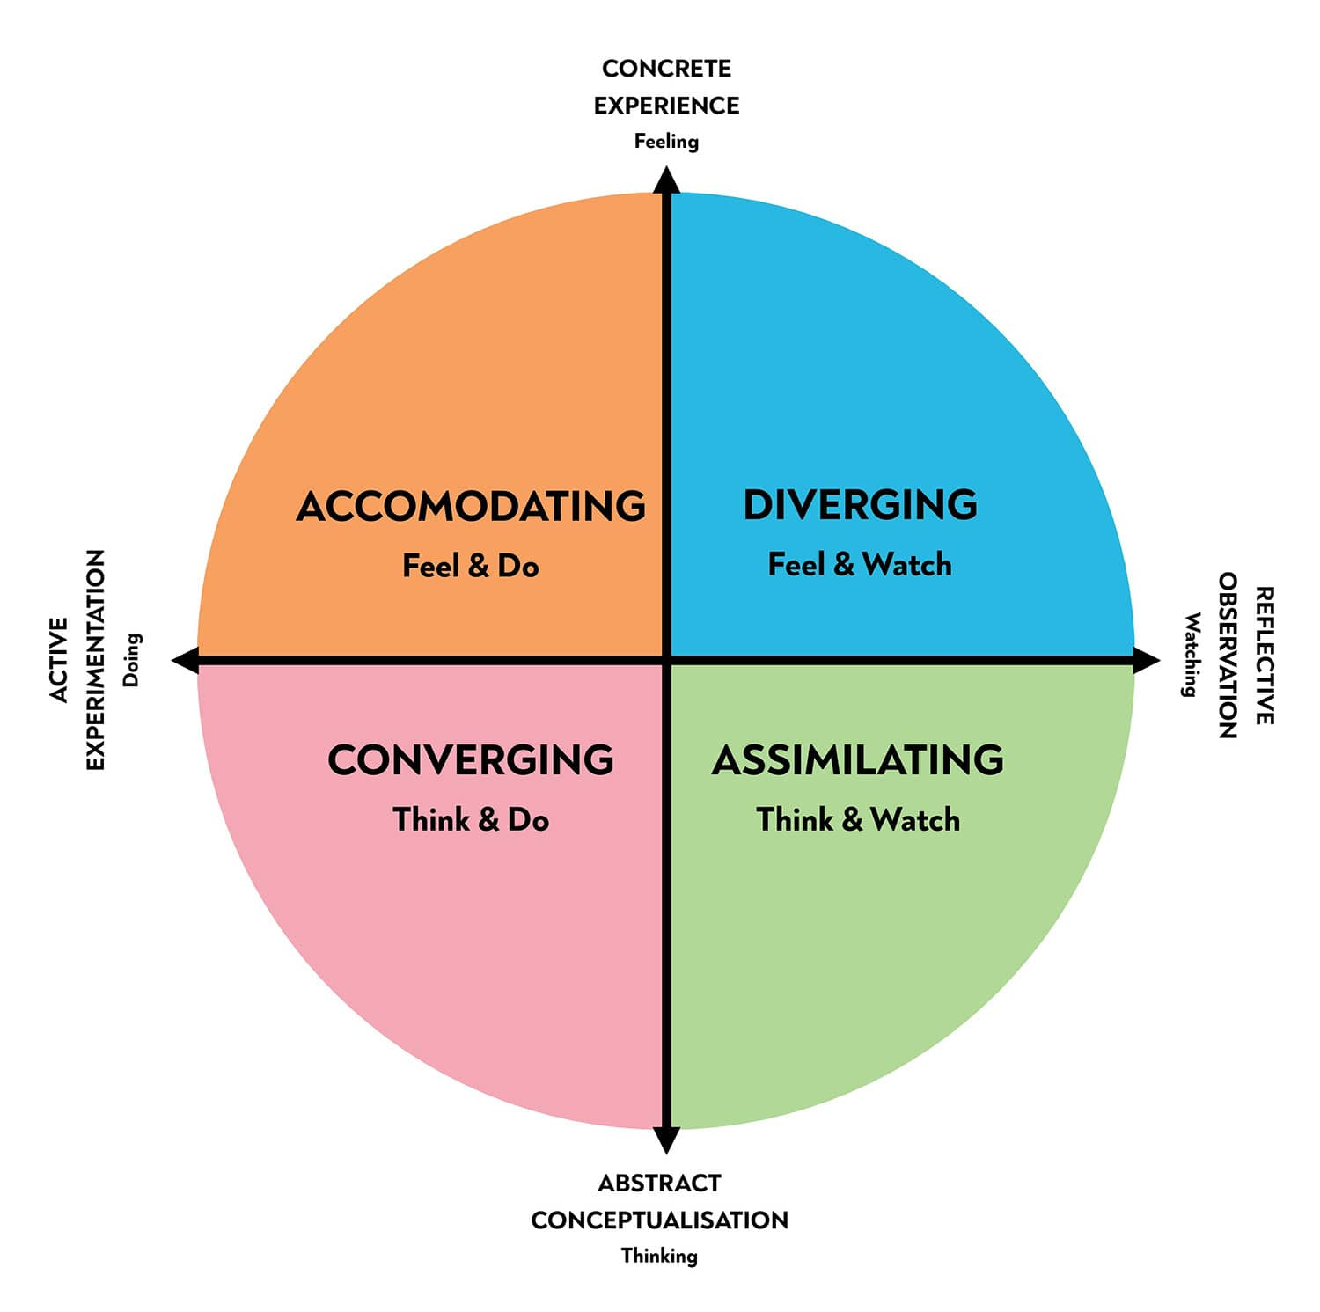
Source: https://www.simplypsychology.org/learning-kolb.html
Manage your time
This is your most critical asset for success. There is a limit to which our body and mind could stay focus. It is recommended by many to keep a learning session approximately two hours. Then you should take a breather.
If you are tired of long hours of offline or online classes, it is very important to have a rest. Say No to all-nighters. A sleepy mind hampers productivity. Although many swear by pulling all-night study sessions before an exam, experts say this is a bad habit because this type of revision only activates a person’s short-term memory. Studying throughout the year leads to better retention when compared to trying to assimilate large chunks of information within a limited time.
Sleep deprivation results in decreased alertness in a test or class, leading to poor academic results. To overcome an endless cycle of delayed assignments, deprived sleep, and low grades, you can never overemphasize the importance of eight hours of shut-eye. Have a good sleep, and have a good break between study sessions, relax your mind. You could do this by watching TV, jog around the neighborhood or go to the park for a walk or yoga.
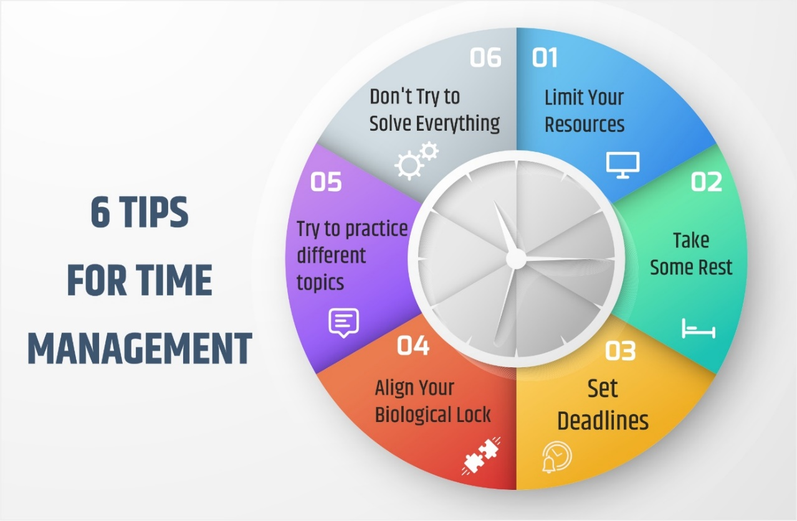
Sources: https://utkarsh.com/blog/blog/time-management-list-of-top-tips-for-managing-time-effectively/
Build your mindset
Of course, good organised daily learning process is important but even more important is your mindset. The root of all success lies in the mind. What you want to achieve, will materialize if you have a clear mindset. A clear mindset will create the purpose for any action. A clear purpose will burn the desire for success.
Mindset as the set of attitudes or beliefs is crucially important because our attitudes and beliefs affect everything we do, feel, think, and experience. Our mindset influences our perceptions and how we move through the life. That is why developing certain mindsets can greatly help to reach goals, enjoy lives, and be more successful.
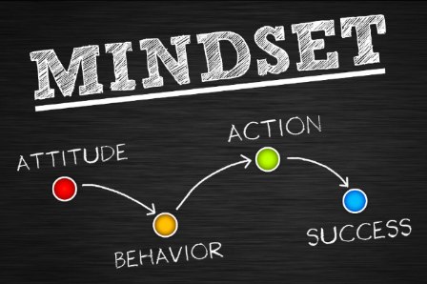
Source: https://thecrnachase.com/6-ways-to-change-your-mindset-to-accomplish-your-goals/
Success in life means attaining your vision of a good life. It means achieving specific goals that result in the future you have planned for yourself. Success in life is defined by you individually. Your vision of success looks different than someone else's. But there are certain the most beneficial mindsets and you can develop them during the life.

Desire

To obtain what you want, you need to define and be very specific on own goals. You need to focus on effort, time, and ideas on one thing, and make it a central part of your life with the aim to have successful career and a fulfilling life.

Since the achievement of goals demands something from you, you need to be aware of what you are willing to put into play to get what you want. Once you are 100% sure and committed to the goals, you must set a date. This will work as motivation and visualization for future actions that you need to take. And finally, you need to plan and act base on that desire, commitment, and the timeline for the goals.

The outcome of this process, which began with desire and ended in planning and execution, needs to be revisited every day, either in the morning or at night. You need to remind yourself of everything what you have created, to remember, visualize and execute accordingly.

Ideas tend to be forgotten, so to keep them alive, you must be aware of their existence every single day.
Ask yourself:
- What are my favorite subjects of interest?
- What would I like to do in the future?
- Do I have timeline for my goals?
Faith

This term is often associated with religions however, faith is the belief in something that goes beyond the rational understanding of why you think it is true. In this case, you need to have faith in yourself and in the idea that everything you desire, planned and execute will take you where you want to be.
Faith does not mean to sit and wait for things to happen, faith is to believe in your goals, in yourself, no matter how hard things turn out to be, no matter how hard the feedback on your person is, you will always have faith.

Faith, like many other things in life, evolves from a very starting phase to a point where it is hard as a rock. You may be in a position where faith is not as strong as you want it to be, or maybe self-confidence makes it easier to have a lot of faith, whatever the case, you need to work on it every day.
Ask yourself:
- Do I belive that my goals are achievable?
- Do I check the progress of the achievements?
- Is my faith strong enough?
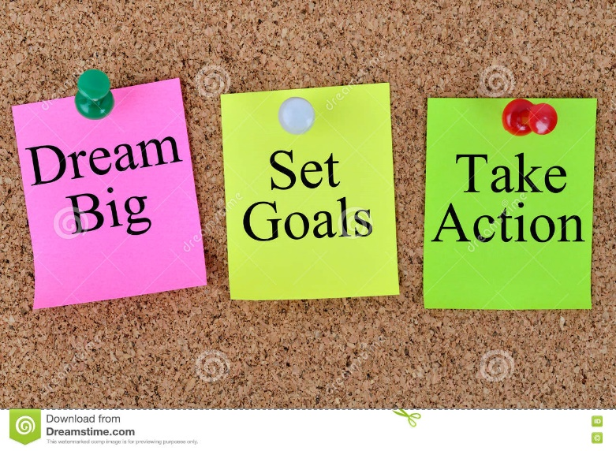
Positive affirmations

One of the most effective ways to increase and maintain faith is by positive affirmations about yourself, your goals, and your progress. It is important to differentiate being positive and affirmative than being naive. You need to be aware of the things you need to change, improve and be better at. But never let these things turn down the trust that you have that at the end.

These affirmations need to be mindful, positive, intelligent, and take you to the level you need to be. The same as desire, for faith, positive affirmation and thinking need to be a habit. This means a daily effort and activity. And this activity is what starts building a great mindset. You have to keep in mind the end goals, visualization of what success looks like, so you can find it more often in own daily life.

You should be able to feel, see and imagine yourself in the spot that you want to be in the future. This way, your deep brain will be programmed to be aware of the things that will take you there.

It is not that by some kind of magic it will appear, it is that your brain will look for things, habits and information to take you there. Your brain will auto-focus on the things that you want.
Ask yourself:
- Do I keep in mind my end goals and picture of the success?
- Do I have things which I need to change and improve?
- Is positive affirmation and thinking my daily habit?
Many of the most successful people in the world agree that the first step towards being successful, whatever success means to each person, starts with a proper mindset.

Specialized knowledge

There are two types of knowledge: the general one, that focus on having an idea of everything but nothing really specific and specialized knowledge into something deep enough.

You need to seek knowledge that is targeted to your goals, by creating a system where you can find the information that you need, to move forward with your ideas, organise this knowledge, and put it into practice.

This does not mean that having general knowledge is bad. It is good to have culture and learn about the world that surrounds us, but is dangerous to assume that this habit of “knowing all”, will pay off in the future for the things that you specifically want. You need to be mindful of what information you are seeking.

Educate yourself for pleasure as well. The more you know about the world you live in, the more questions you will have and the more interested you will be. But keep in mind that it is hard nowadays to be focused on specialized knowledge when you have a lot of information, and in general, 99% of the daily input that you have will be worthless to your end goals. So, it is important to analyze the information that you seek, limit input, and take what you need for the achievement of your goals.
Ask yourself:
- What would I want to specialized in?
- What information I need to find and where?
- What I do to develop my general knowledge?
Imagination

Imagination designs thoughts, ideas, and in general life. There are two types of imagination. One can gather pieces of information you know or can learn and assemble something new but known.

The other type of imagination helps to create things that you have never seen before. That type of imagination is not based on knowledge or experience, it creates new ideas and thoughts in your mind, designs desire, creates plans and actions that you can follow every day.

Organised planning

You can have desire, imagination, and faith, but without a plan, there is no path in front of you. This step is very important, it is the one that takes you into action and forces your hand to, instead of being on the sidelines. You have to be a main player in the game!

In this planning, you need to have a mindset for success and be capable of adapting quickly to change. You do not create a plan to see what happens or hoping for the best. You should create a plan that you believe in, and that you know will take you to your end goal.

Here is where everything comes together: desire, faith, knowledge, creativity, and visualization. Create a plan that you can follow every day for your learning process, exams and future career.
Ask yoursef:
- What kind of immagination I have?
- Do I have a plan?
- What are details of this plan?
Source: https://ru.depositphotos.com/85668202/stock-photo-a-goal-without-a-plan.html
Persistence

This is a value and the ability to keep moving forward, even when things get rough. The mentality should be, keep moving forward.

Never quit. Most people quit at the first one, then at the second, but the ones that remain after 5 or 10 obstacles in the road, are the ones that in the end succeed. This is why it is important to be resourceful, creating and applying techniques to overcome obstacles, to go above them, through them, around them, whatever it takes to leave that obstacle behind.

If your mind is being programmed for success, the deep brain will continue with actions even you are not aware of them. Thoughts create actions. That is why it is so important that you are mindful of your thoughts, actions, and programming of the deep brain. Such mindset creates a successful life.

Start living your dreams
Success and happiness require struggle. You have to find a way to appreciate the uncertainty, the risk, the repeated failures, and work insane hours on something you have no idea whether or not it will be successful. The quality of your life is not determined by the quality of your positive experiences, but the quality of your negative experiences. And to get good at dealing with negative experiences is to get good at dealing with life.

In order to achieve your dreams and be the person you want to be, you will have to start paying attention to your actions. Ask yourself, "Is what I'm doing going to lead me to where I want to be in life?"

If you find yourself constantly bored, daydreaming about the future or past or counting down the minutes until the day ends, it is probably because you feel disconnected from what you are doing. Try to spend your free time doing things that you enjoy doing, rather than wasting time. For example, rather than spending your weekends watching television, spend them partaking in your hobbies or spending time with loved ones and new friends. Activities should be engaging and enjoyable.

Keep in mind that it is perfectly fine to spend some time doing nothing and just being lazy each day. This can actually help with your imagination and self-awareness. Strive for a balance between doing things you want to do and allowing yourself to just "be."

From other side, if you want the benefits of something in life, you have to also want the costs. If you find yourself wanting something month after month, year after year, yet nothing happens and you never come any closer to it, then maybe what you actually want is a fantasy, an idealization, an image, a false promise. Maybe what you want isn’t what you want — you just enjoy wanting. Maybe you don’t actually want it at all.
Maybe, you are in love with the result but you are not in love with the process. Maybe, you just liked to imagine the top. Life doesn’t work that way.

Ask yoursef:
- Did I try hard enough?
- Am I courageous enough to live my dreams?
- What I did for that?
Who you are is defined by the dreams you are willing to struggle for. People who enjoy the struggles are the ones who get results. This is not a call for willpower or “grit.” This is not admonition of “no pain, no gain.” This is the most simple and basic component of life: our struggles determine our successes. So, choose your dreams and struggles wisely.

Tasks

Set SMART goals: goals that are specific, measurable, achievable, relevant, and time-bound.

Sources: https://www.kom-dir.ru/article/3596-smart-tseli

Make a list of your goals, and what you might do to achieve them.
- Be sure to address both short-term and long-term goals.
- Try to think beyond financial and career goals, such as relationship goals, personal goals for bettering yourself, things you would like to experience, or things you want to learn.
- Draw up a timeline that says when you want to achieve each part. Be honest about your limits.
- Make commitments to yourself, and stick to them. Write down your commitments and hang them in places you can see.
- Make sure that your commitments are gradually moving you towards your goals. Review your goals now and then to make sure you are moving in the right direction.

Remember:

1. “It's never too late to learn.”

2. “It's ok if I fail, at least I learned something.”

3. “I appreciate constructive criticism.”

4. “I'm good at something.”

5. “I won't fail if I don't try.”

Evaluation

Evaluate your abilities from 1 to 10 points. 1 - I'm completely unable to... 10 – perfectly able to....

 | Skills | Evaluation
 | I know my learning styles
 | I have goals for my life
 | I know in what I will specialized
 | I have plan for my actions

References:
  - https://turningpointcentre.com/identifying-your-learning-style.html
  - https://byrslf.co/a-proper-mindset-to-succeed-a92d1b2ca26b
  - https://www.skillshub.com/what-are-kolbs-learning-styles/
  - https://medium.com/@giogiovanninaranjo/everybody-wants-what-feels-good-9a01120b9fbe
  - https://www.simplypsychology.org/learning-kolb.html
  - https://www.berkeleywellbeing.com/mindsets.html
  - https://www.oberlo.com/blog/how-to-be-successful
  - https://utkarsh.com/blog/blog/time-management-list-of-top-tips-for-managing-time-effectively/
  - https://www.verywellmind.com/how-to-become-a-more-effective-learner-2795162
  - https://rescuestreetchild.com/study-smart-and-learn-faster/
  - https://learningcenter.unc.edu/tips-and-tools/studying-101-study-smarter-not-harder/
  - https://thecollegepost.com/best-study-methods/
  - https://thecrnachase.com/6-ways-to-change-your-mindset-to-accomplish-your-goals/
  - https://books.google.ee/books?id=32XEDQAAQBAJ&printsec=frontcover&dq=Kolb+learning+styles&hl=en&sa=X&ved=2ahUKEwiDgNHK0sv3AhWhk4sKHTnPANsQ6AF6BAgKEAI#v=onepage&q=Kolb%20learning%20styles&f=false
  - https://www.youtube.com/watch?v=x_dXip0J37g
  - https://www.youtube.com/watch?v=w1cX89XgqUM
  - https://www.youtube.com/watch?v=V2_2UGeGL9M
  - https://www.youtube.com/watch?v=RkbmMMXsfn0
  - https://www.youtube.com/watch?v=rycjUldMl3k

